Jenkins: Prevent Parallel Pipeline Builds on the Same Node
Practical Implementation Guide | CI/CD | Jenkins Pipelines

1. Objective
Prevent two Jenkins pipeline executions of the same type from running at the same time on the same Jenkins node/agent when the builds share resources such as deployment directories, ports, workspaces, configuration files, test environments, or application servers.

2. Problem Statement
Consider two pipeline jobs, Pipeline-A and Pipeline-B, that use the same Linux agent. If both are allowed to execute simultaneously, they may compete for the same resources.
- Pipeline-A starts deployment to Tomcat.
- Pipeline-B starts another deployment to the same Tomcat server.
- Both pipelines may modify the same files or application directory.
- One build can overwrite files created by the other build.
- The result can be an inconsistent deployment, failed tests, or an unstable application.

3. Important Jenkins Concepts
Option | What it controls | Use case
disableConcurrentBuilds() | Same Jenkins job | Prevents two builds of the same job from running concurrently.
Lockable Resources | Shared resource across different jobs | Best when different jobs must serialize access to the same node/resource.
Throttle Concurrent Builds | Concurrency by category/node/label | Useful for limiting the number of builds across a group of jobs.
Node/label restriction | Where a job runs | Ensures builds use the intended agent, but does not by itself prevent parallel execution.
Key point: assigning the same node label to two jobs does not automatically make them run one after another. Jenkins can run multiple executors on the same node. A concurrency-control mechanism is required.

4. Recommended Solution
For two or more different pipeline jobs that are the same type and must not access a shared resource simultaneously, use the Lockable Resources plugin. Create a lock resource representing the shared node/resource and acquire that lock around the stages that must be serialized.
If the requirement is only 'the same Jenkins job must not have two builds running at the same time', use disableConcurrentBuilds() instead.

5. Solution A — Prevent Concurrent Builds of the Same Job

5.1 Jenkinsfile
pipeline {
agent { label 'linux' }
options {
disableConcurrentBuilds()
}
stages {
stage('Build') {
steps {
sh 'mvn clean package'
}
}
stage('Deploy') {
steps {
sh './deploy.sh'
}
}
}
}

5.2 How it works
- Build #10 starts.
- Build #11 of the same job is triggered while Build #10 is running.
- Jenkins does not run Build #11 concurrently with Build #10.
- Depending on the configuration, the newer build waits in the queue or older-build handling can be configured.
This solution does NOT coordinate two different Jenkins jobs. For example, Pipeline-A and Pipeline-B can still run at the same time if each job separately uses disableConcurrentBuilds().

6. Solution B — Recommended for Different Jobs Sharing One Resource

6.1 Install Lockable Resources Plugin
- Open Jenkins → Manage Jenkins → Plugins.
- Search for 'Lockable Resources'.
- Install the plugin and restart Jenkins if Jenkins requests a restart.
- Open Manage Jenkins → System and locate the Lockable Resources section.
- Create a lockable resource, for example: linux-deployment-node-1.
The resource can represent an actual node, a deployment environment, a Tomcat server, a database, or any other resource that must be accessed by only one build at a time.

6.2 Jenkinsfile using lock()
pipeline {
agent { label 'linux' }
stages {
stage('Build') {
steps {
sh 'mvn clean package'
}
}
stage('Deploy to Shared Environment') {
steps {
lock(resource: 'linux-deployment-node-1') {
sh '''
echo "Lock acquired"
./deploy.sh
echo "Deployment completed"
'''
}
}
}
}
}
Only the code inside the lock block is serialized. This is usually better than locking the entire pipeline because build, unit-test, and artifact-creation stages can run concurrently while the shared deployment operation remains protected.

7. Example: Two Different Jobs Using the Same Lock

Pipeline-A
pipeline {
agent { label 'linux' }
stages {
stage('Build') {
steps {
sh 'mvn clean package'
}
}
stage('Deploy') {
steps {
lock(resource: 'linux-deployment-node-1') {
sh './deploy-app-a.sh'
}
}
}
}
}

Pipeline-B
pipeline {
agent { label 'linux' }
stages {
stage('Build') {
steps {
sh 'mvn clean package'
}
}
stage('Deploy') {
steps {
lock(resource: 'linux-deployment-node-1') {
sh './deploy-app-b.sh'
}
}
}
}
}
If Pipeline-A obtains the lock first, Pipeline-B waits. After Pipeline-A releases the lock, Pipeline-B can acquire it and continue. The reverse order is also possible.

8. Lock Only the Critical Section
A common real-time best practice is to keep the lock scope as small as possible.
Recommended:
stage('Build') {
steps {
sh 'mvn clean package'
}
}
stage('Deploy') {
steps {
lock(resource: 'linux-deployment-node-1') {
sh './stop-tomcat.sh'
sh './copy-war.sh'
sh './start-tomcat.sh'
sh './health-check.sh'
}
}
}
Avoid locking the entire pipeline unless every stage truly requires exclusive access.

9. Solution C — Disable Concurrent Builds with Abort Option
pipeline {
agent { label 'linux' }
options {
disableConcurrentBuilds(abortPrevious: true)
}
stages {
stage('Build') {
steps {
sh 'mvn clean package'
}
}
}
}
With abortPrevious: true, when a newer build starts, Jenkins aborts the currently running older build of the same job and proceeds with the newer build. This is useful for jobs where only the latest commit matters, but it should be used carefully for deployments because abruptly stopping a deployment can leave an environment in an intermediate state.

10. Solution D — Throttle Concurrent Builds
The Throttle Concurrent Builds plugin can be used when you want to control concurrency across a category of jobs. For example, you can create a category for production deployments and limit the number of concurrent executions to one.
- Create a throttle category, for example: production-deployment.
- Set the maximum total concurrent builds to 1.
- Assign the relevant pipeline jobs to that category.
- Optionally apply node or label restrictions according to the environment.
This approach is useful when the organization has many jobs that belong to the same deployment class. For a single shared resource, Lockable Resources is generally more direct and easier to understand.

11. Node Executors — Important Check
Even if two jobs use the same node, Jenkins may execute them simultaneously when the node has multiple executors.
Manage Jenkins
→ Nodes
→ Select the Agent
→ Configure
→ Number of executors
Setting the number of executors to 1 ensures only one executor on that node can run a build at a time. However, this is a node-wide restriction: it blocks unrelated jobs from using the second executor as well. Therefore, do not reduce executors to 1 just to solve a problem that could be isolated with a lock.

12. Recommended Architecture for a Shared Deployment Node
Jenkins Controller
|
+-----------------+-----------------+
| |
Pipeline-A Pipeline-B
| |
+----------- same lock -------------+
|
Lock: linux-deployment-node-1
|
Jenkins Agent
|
Tomcat / App
Pipeline-A and Pipeline-B can perform independent build activities, but they must acquire the same lock before touching the shared deployment environment.

13. Step-by-Step Implementation
- Identify the resource that must not be accessed concurrently: Jenkins node, Tomcat server, deployment directory, test environment, or another shared resource.
- Decide whether the restriction applies to the same job only or to multiple jobs. Use disableConcurrentBuilds() for one job; use Lockable Resources for a shared resource across jobs.
- Confirm the Jenkins agent label, for example 'linux'.
- Install the Lockable Resources plugin if using the lock approach.
- Create a lockable resource named 'linux-deployment-node-1'.
- Add the lock(resource: 'linux-deployment-node-1') block around the deployment/critical section.
- Trigger Pipeline-A and Pipeline-B close together.
- Observe that one pipeline acquires the lock and the other waits.
- After the first pipeline completes the locked section, the waiting pipeline acquires the lock.
- Check the deployment logs and application health to confirm there is no simultaneous deployment.

14. Verification / Testing
- Trigger Pipeline-A.
- Immediately trigger Pipeline-B.
- Open both Console Outputs.
- Verify that only one pipeline enters the locked section at a time.
- The second pipeline should show that it is waiting for the lock/resource.
- After the first pipeline releases the lock, verify that the second pipeline continues.
- Confirm the application is healthy after each deployment.
- Test the behavior again with three or more jobs if the resource is shared by multiple pipelines.

15. Common Mistakes
Mistake | Why it is a problem
Using the same node label | A label only selects eligible nodes. It does not prevent concurrent builds.
Using disableConcurrentBuilds() in both jobs | It prevents concurrency within each job, but Job-A and Job-B can still run together.
Setting node executors to 1 unnecessarily | It serializes every job on that node, including unrelated jobs.
Locking only one of the pipelines | All pipelines that access the shared resource must use the same lock resource name.
Locking too much of the pipeline | Long lock durations reduce throughput. Lock only the critical/shared-resource section.
Using abortPrevious for critical deployments | An interrupted deployment can leave the environment partially changed. Prefer queueing/locking when safe serialization is required.

16. Best-Practice Recommendation
For a real CI/CD environment, use the least restrictive mechanism that satisfies the requirement:
- Same job, no parallel builds required → disableConcurrentBuilds().
- Same job, latest build should replace old build → disableConcurrentBuilds(abortPrevious: true), only when safe.
- Different jobs share one deployment/server/environment → Lockable Resources.
- Large group of jobs needs a concurrency policy → Throttle Concurrent Builds.
- Node should never run more than one build of any kind → configure the node with one executor, but use this deliberately.

17. Interview Answer — Real-Time Scenario
Question: 'How do you prevent two Jenkins pipeline jobs of the same type from running in parallel on the same node?'
Answer:
First, I identify whether the concurrency restriction is for the same Jenkins job or for multiple jobs sharing a resource. For the same job, I use disableConcurrentBuilds() in the Jenkinsfile. If multiple pipeline jobs must share the same node, Tomcat server, deployment directory, or environment and must not access it simultaneously, I use the Lockable Resources plugin. I create one lock resource and use the same lock name in all relevant pipelines. Only the deployment or other critical section is wrapped inside lock(), so build and test stages can still run in parallel. I then verify that one pipeline acquires the lock while the other waits, and that the waiting pipeline continues after the first one releases it.

18. Quick Reference
Requirement | Recommended Method | Example
Prevent same job from running twice | disableConcurrentBuilds() | options { disableConcurrentBuilds() }
Abort old build when new build starts | disableConcurrentBuilds(abortPrevious: true) | Latest build wins
Serialize different jobs sharing a resource | Lockable Resources | lock(resource: 'linux-deployment-node-1')
Limit concurrency for a group of jobs | Throttle Concurrent Builds | Category limit = 1
Allow only one build on an entire node | Node executors = 1 | Use only when node-wide serialization is intended

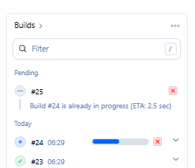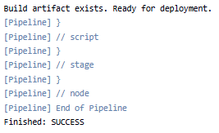

TASK -1 How to Prevent Two Pipeline Jenkins Jobs of the Same Type to Run in Parallel on the Same Node?

Introduction
In Jenkins, we need to control how our pipeline jobs run. We often need to ensure that our system uses resources properly and that conflicts between jobs are avoided.
One common scenario we face is the need to prevent two pipeline jobs of the same type from running in parallel on the same node. When jobs run concurrently on one node, they might compete for CPU, memory, or disk I/O. They may also share the same workspace, leading to file conflicts or even inconsistent outcomes.
In this tutorial, we explain several methods we can use to control job concurrency on a single node.

2. Understanding the Need to Restrict Parallel Execution
Running multiple instances of the same pipeline on one node can lead to several problems.
First, resource contention is a major concern. When two jobs use a lot of memory or CPU simultaneously, they may slow each other down or even fail if the node runs out of resources. For example, suppose one job runs a heavy build process while another job on the same node performs resource-intensive tests. In that case, we might see significant delays or failures due to insufficient memory or CPU allocation.
Second, there is a risk of workspace conflicts. By default, Jenkins uses the same workspace directory for all job builds. This means that if two builds run concurrently, files might be overwritten or become corrupted. We have experienced situations where simultaneous writes led to unstable behavior in our build process, making it hard to track down the source of errors. These issues may result in unpredictable build outcomes and make debugging very challenging.
Third, modifying shared resources can cause data corruption. If our jobs change shared resources or update common files, one job might interfere with another. Such interference could lead to corrupted outputs, failing tests, or even security vulnerabilities if sensitive data is modified unexpectedly.
The overall goal is to ensure that only one instance of a particular type of job runs on a given node at any time while still allowing multiple jobs to run on different nodes concurrently. This approach helps us maintain a robust and efficient continuous integration pipeline.

3. Using the disableConcurrentBuilds Option
Jenkins offers a built-in way to prevent concurrent executions: using the disableConcurrentBuilds option in a declarative pipeline. This option guarantees that if one instance of our pipeline runs, no new instance will start until the current one finishes. This method is straightforward and works regardless of which node the job is running on.
Below is a code sample that we can copy and paste into our Jenkins file:
pipeline {

agent any

options {
disableConcurrentBuilds()
}

stages {

stage('Build') {
steps {
echo 'Starting Maven Build...'

sh '''
mvn clean package -DskipTests
'''
}
}

stage('Test') {
steps {
echo 'Starting Integration Tests...'

sh '''
docker --version
docker compose version

mvn test
'''
}
}
}

post {
success {
echo 'Build and Test completed successfully.'
}

failure {
echo 'Build or Test failed.'
}

always {
echo 'Pipeline execution completed.'
}
}
}
In the sample above, the disableConcurrentBuilds option stops a new pipeline instance from starting until the running instance is completed. This approach applies globally and does not differentiate between nodes. This means that even if we have multiple nodes available, only one build of the job can run at any time. While this method is simple and effective, it might be too strict for environments where we want to allow parallel builds on different nodes.
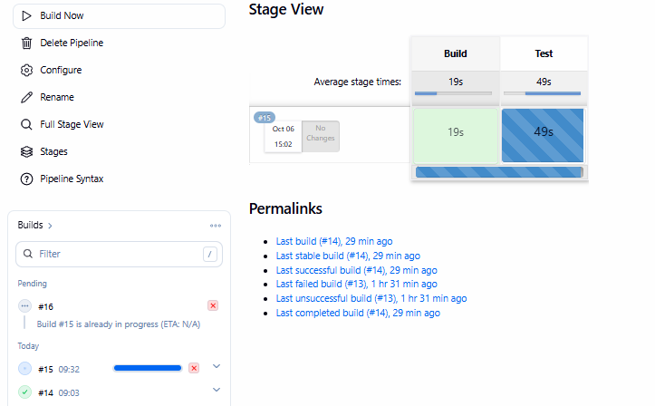
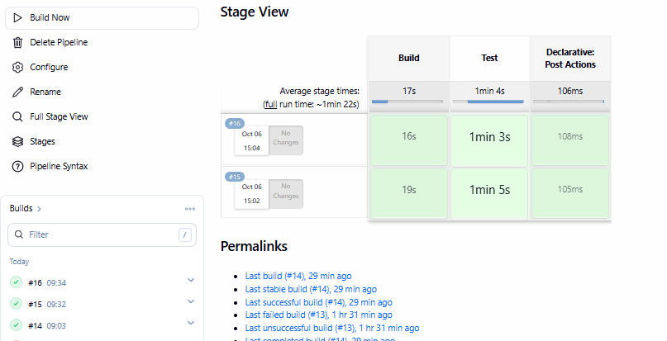
4. Utilizing the Throttle Concurrent Builds Plugin
For more granular control, especially when we want to allow parallel builds across nodes but not on a single node, the Throttle Concurrent Builds Plugin offers the necessary flexibility. This plugin will enable us to group jobs into categories and limit how many jobs from the same category can run concurrently on a node. By grouping jobs and setting the maximum number of concurrent builds per node to one, we ensure that only one job from a category is active on any single node.

4.1. Install the Plugin
The first step is to install the plugin:
- Go to Manage Jenkins and then Manage Plugins
- In the Available tab, search for the Throttle Concurrent Builds Plugin
- Select the plugin and install it without restarting if possible
Installing the plugin is straightforward. Once installed, it provides additional configuration options not available by default in Jenkins.
4.2. Configure Throttle Categories
After installing the plugin, we need to configure a throttle category. This category will define how many builds can run on a node for jobs that belong to it:
- Go to Manage Jenkins and then Configure System
- Scroll down to the section labeled Throttle Concurrent Builds
- Under Categories, click the button to add a new category
- Enter a name for the category, for example, myThrottleCategory
- Set the Maximum Concurrent Builds Per Node to 1. This setting ensures that no more than one job from this category runs on a single node
- Optionally, we can set the Maximum Total Concurrent Builds to control the overall number of builds running across all nodes
- Another option is to set the Maximum Concurrent Builds Per Node Labeled, which allows us to specify the name of the nodes that should have limitation
By setting these limits, we give ourselves precise control over job execution. This allows us to run multiple builds concurrently across different nodes while ensuring that no node is overloaded by running more than one instance of the same job.
The final configuration will look similar to this one:

Those of us using a declarative pipeline can also integrate these settings into our Jenkinsfile using the throttleJobProperty option:
pipeline {
agent any
options {
throttleJobProperty(
categories: ['MyThrottleCategory'],
throttleEnabled: true,
throttleOption: 'category'
)
}
stages {
stage('Build') {
steps {
// Insert build steps here
}
}
stage('Test') {
steps {
// Insert test steps here
}
}
}
}
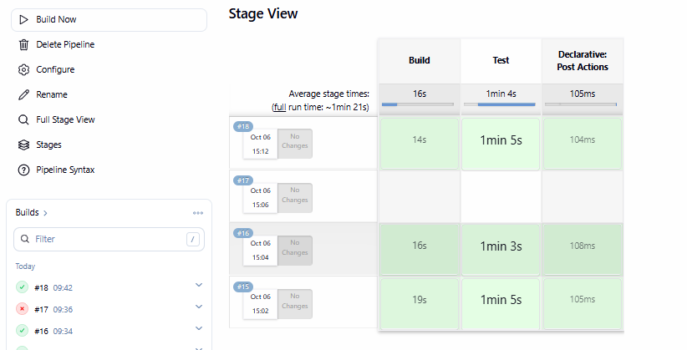

5.Implementing Node-Level Locks with the Lockable Resources Plugin
Another approach to controlling concurrent job execution is to use the Lockable Resources Plugin. This plugin gives us a mechanism to lock resources, such as a node or a specific resource on a node before a job runs. Doing so ensures that only one job can access the locked resource.
After installing the plugin, we need to define a resource the job will lock:
- Go to Manage Jenkins and then Configure System
- Scroll down to the section labeled Lockable Resources
- Click the option to add a new lockable resource
- Give the resource a unique name, for example, MyJobResource
- Optionally add labels or a description to help us identify the resource
- Save the configuration
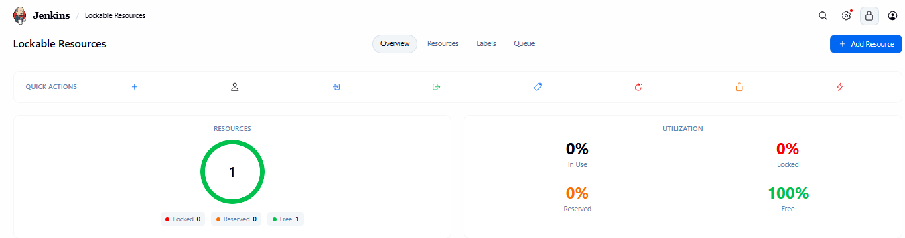
Once the resource is defined, we modify our pipeline script to use the lock step. The lock step ensures that our job obtains an exclusive lock on the resource before executing a critical section of the code. Below is a code sample that we can copy and paste into our Jenkinsfile:
pipeline {
agent any
stages {
stage('Preparation') {
steps {
lock(resource: 'MyJobResource') {
// This block is locked. Only one job on the same node can run this section at a time.
echo 'Lock acquired, running the critical section'
// Place critical operations here
}
}
}
stage('Other Steps') {
steps {
// Other steps that do not require locking can run in parallel.
echo 'Running other operations'
}
}
}
}
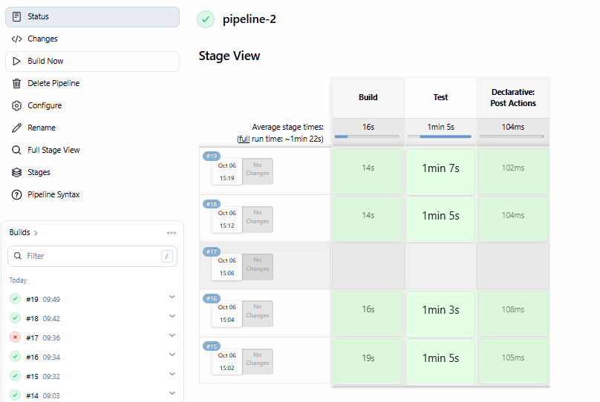

TASK-2 . Jenkins Documentation: Check if a File Exists in a Jenkins Pipeline

1. Objective
To verify whether a specific file exists in the Jenkins workspace before performing an operation.
This is useful when you want to:
- Verify that source code was checked out successfully.
- Check whether pom.xml exists before running Maven.
- Check whether a configuration file exists.
- Check whether a deployment artifact such as .war or .jar was created.
- Prevent pipeline failures caused by missing files.
- Add conditional logic based on the presence or absence of a file.

2. Prerequisites
Before performing this activity, ensure:
- Jenkins is installed and running.
- A Jenkins Pipeline job is available.
- A Jenkins agent/node is available.
- Git is configured if the pipeline checks out source code.
- The required file is available in the workspace or is expected to be created during the pipeline.
Example workspace:
/var/lib/jenkins/workspace/pipeline-1
Example project:
pipeline-1/
├── pom.xml
├── src/
├── README.md
└── Jenkinsfile

3. Method 1: Using fileExists()
The recommended Jenkins Pipeline method is:
fileExists('filename')
It returns:
true
if the file exists, and:
false
if the file doesn't exist.

Basic example
pipeline {
agent any

stages {

stage('Check File') {
steps {
script {
if (fileExists('pom.xml')) {
echo 'pom.xml exists'
} else {
echo 'pom.xml does not exist'
}
}
}
}
}
}

4. Understanding the Pipeline
The important part is:
if (fileExists('pom.xml')) {
Jenkins checks for:
pom.xml
inside the current workspace.
For example:
/var/lib/jenkins/workspace/pipeline-1/pom.xml
If it exists:
pom.xml exists
will be printed.
If it doesn't:
pom.xml does not exist
will be printed.

5. Check a File Before Running Maven
This is a very practical DevOps use case.
If Maven is executed without a pom.xml, you can get:
The goal you specified requires a project to execute
but there is no POM in this directory
Instead, check the file first.
pipeline {
agent any

stages {

stage('Git Checkout') {
steps {
git branch: 'main',
url: 'https://github.com/betawins/hiring-app.git'
}
}

stage('Check pom.xml') {
steps {
script {
if (fileExists('pom.xml')) {
echo 'pom.xml found'
} else {
error 'pom.xml not found in Jenkins workspace'
}
}
}
}

stage('Maven Build') {
steps {
sh 'mvn clean package'
}
}
}
}

Pipeline flow
Git Checkout
|
v
Check pom.xml
|
+------ File exists ------> Maven Build
|
|
+------ File missing -----> Pipeline fails

6. Using fileExists() with a Directory
You can also check whether a directory exists.
Example:
script {
if (fileExists('src')) {
echo 'src directory exists'
} else {
echo 'src directory does not exist'
}
}
However, remember that fileExists() is primarily useful for checking whether the specified workspace path exists. For more detailed file/directory checks, shell commands such as test -f and test -d can be used.

7. Check a File in a Subdirectory
Suppose your workspace looks like:
pipeline-1/
└── hiring-app/
├── pom.xml
└── src/
You can check:
pipeline {
agent any

stages {

stage('Check POM') {
steps {
script {
if (fileExists('hiring-app/pom.xml')) {
echo 'pom.xml found'
} else {
error 'pom.xml not found'
}
}
}
}
}
}

8. Using dir() with fileExists()
Another clean approach is:
stage('Check POM') {
steps {
dir('hiring-app') {
script {
if (fileExists('pom.xml')) {
echo 'pom.xml exists'
} else {
error 'pom.xml does not exist'
}
}
}
}
}
Here Jenkins changes the working directory to:
hiring-app/
Therefore:
fileExists('pom.xml')
checks:
hiring-app/pom.xml

9. Check for a Build Artifact
Suppose Maven generates:
target/hiring-0.1.jar
You can verify it before deployment.
stage('Check Artifact') {
steps {
script {
if (fileExists('target/hiring-0.1.jar')) {
echo 'JAR file generated successfully'
} else {
error 'JAR file was not generated'
}
}
}
}
This is very useful before:
Nexus Upload
↓
Docker Build
↓
Tomcat Deployment

10. Check WAR File Before Tomcat Deployment
For a Java web application:
stage('Check WAR') {
steps {
script {
if (fileExists('target/hiring-0.1.war')) {
echo 'WAR file exists'
} else {
error 'WAR file not found'
}
}
}
}
Then deploy:
stage('Deploy') {
steps {
sh '''
scp target/hiring-0.1.war ec2-user@SERVER:/opt/tomcat/webapps/
'''
}
}
This prevents Jenkins from attempting to deploy a nonexistent artifact.

11. Check Multiple Files
You can check multiple files individually:
stage('Validate Files') {
steps {
script {

if (!fileExists('pom.xml')) {
error 'pom.xml is missing'
}

if (!fileExists('src')) {
error 'src directory is missing'
}

echo 'Required files/directories are available'
}
}
}

12. Using Shell test -f
Another approach is Linux's test command.
stage('Check File') {
steps {
sh '''
if [ -f pom.xml ]; then
echo "pom.xml exists"
else
echo "pom.xml does not exist"
exit 1
fi
'''
}
}

Explanation
[ -f pom.xml ]
means:
Check whether pom.xml exists and is a regular file.
If it exists:
pom.xml exists
If it doesn't:
pom.xml does not exist
and:
exit 1
causes the Jenkins stage to fail.

13. fileExists() vs test -f
Method | Example | Recommended for
Jenkins fileExists() | fileExists('pom.xml') | Jenkins Pipeline logic
Linux test -f | [ -f pom.xml ] | Shell/Linux operations
ls | ls pom.xml | Quick troubleshooting
find | find . -name pom.xml | Locating unknown files
For Jenkins Pipeline conditions, fileExists() is generally the cleanest option.

14. Troubleshooting Missing pom.xml
If you receive:
The goal you specified requires a project to execute
but there is no POM in this directory
add this stage:
stage('Workspace Verification') {
steps {
sh '''
echo "Current directory:"
pwd

echo "Workspace contents:"
ls -la

echo "Searching for pom.xml:"
find . -name pom.xml -print
'''
}
}
This tells you:
- Where Jenkins is currently working.
- What files are present.
- Where pom.xml actually exists.
For example:
/var/lib/jenkins/workspace/pipeline-1

./hiring-app/pom.xml
Then your Maven command needs to run inside hiring-app:
dir('hiring-app') {
sh 'mvn clean package'
}

15. Complete Real-Time Example
This is a good example for a Jenkins + Git + Maven CI pipeline:
pipeline {
agent any

stages {

stage('Git Checkout') {
steps {
git branch: 'main',
url: 'https://github.com/betawins/hiring-app.git'
}
}

stage('Workspace Verification') {
steps {
sh '''
echo "Workspace:"
pwd

echo "Files:"
ls -la

echo "POM files:"
find . -name pom.xml -print
'''
}
}

stage('Check POM') {
steps {
script {
if (fileExists('pom.xml')) {
echo 'pom.xml found successfully'
} else {
error 'pom.xml not found. Maven build cannot continue.'
}
}
}
}

stage('Maven Build') {
steps {
sh 'mvn clean package'
}
}

stage('Check Artifact') {
steps {
script {
if (fileExists('target')) {
echo 'target directory exists'
} else {
error 'target directory was not created'
}
}
}
}
}

post {
success {
echo 'Pipeline completed successfully'
}

failure {
echo 'Pipeline failed. Check the console output.'
}
}
}

16. Best Practice
In a real CI/CD pipeline, use file checks at important boundaries:
Git Checkout
|
v
Check pom.xml
|
v
Maven Build
|
v
Check JAR/WAR Artifact
|
v
SonarQube Analysis
|
v
Nexus Upload
|
v
Deployment
For example:
if (!fileExists('pom.xml')) {
error 'Required pom.xml is missing'
}
and:
if (!fileExists('target/app.war')) {
error 'Required WAR artifact is missing'
}
This makes the pipeline fail early with a clear error message, rather than allowing a later stage to fail with a confusing error.

Key interview answer
How do you check whether a file exists in Jenkins Pipeline?
A good practical answer is:
"I use the Jenkins Pipeline fileExists() step. It returns true or false depending on whether the specified path exists in the current workspace. For example, before running Maven, I can check fileExists('pom.xml'). If the POM is missing, I use the error() step to stop the pipeline with a meaningful message."

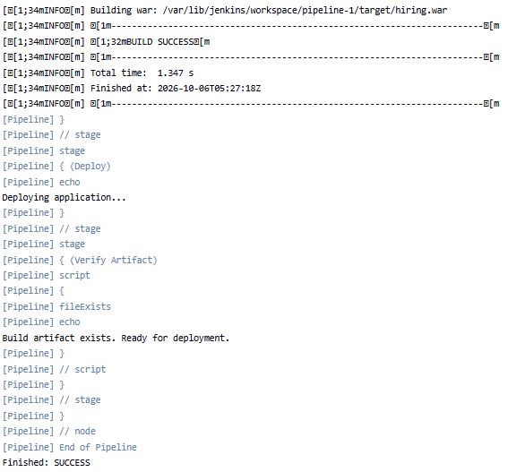

TASK-3.Set Stage Status in Jenkins Pipelines

1. Objective
The objective of this document is to explain how to set, control, and display the status of individual stages in a Jenkins Pipeline.
In real-time CI/CD pipelines, stage status helps us identify whether a particular activity such as:
- Git Checkout
- Build
- Unit Testing
- SonarQube Analysis
- Docker Build
- Nexus Upload
- Deployment
was successful, unstable, skipped, or failed.
This is especially useful when troubleshooting pipeline failures and when sending notifications to development or operations teams.

2. What Is Stage Status?
A Jenkins Pipeline consists of multiple stages.
For example:
Pipeline
|
+-- Git Checkout
|
+-- Maven Build
|
+-- Unit Test
|
+-- SonarQube
|
+-- Docker Build
|
+-- Deploy
Each stage can have a status.
Common statuses include:
Status | Meaning
SUCCESS | Stage completed successfully
FAILURE | Stage failed
UNSTABLE | Stage completed but has warnings/problems
ABORTED | Pipeline/stage was manually stopped
NOT_BUILT | Stage was not executed

3. Prerequisites
Before implementing stage status handling, ensure:
- Jenkins is installed and running.
- A Pipeline job is available.
- Jenkins Pipeline syntax is understood.
- A Jenkins agent/node is available.
- Required tools such as Git, Maven, Docker, etc. are configured if used by the pipeline.

4. Basic Stage Status
Normally, Jenkins automatically determines the stage status.
Example:
pipeline {
agent any

stages {

stage('Build') {
steps {
sh 'mvn clean package'
}
}

}
}
If Maven succeeds:
Build
|
+---- SUCCESS
If Maven fails:
Build
|
+---- FAILURE
Jenkins automatically marks the stage based on the result of the steps inside it.

5. Manually Set the Build Status
Jenkins provides the currentBuild.result property to set the overall build result.
Example:
pipeline {
agent any

stages {

stage('Build') {
steps {
script {
currentBuild.result = 'SUCCESS'
echo 'Build marked as SUCCESS'
}
}
}
}
}

Available build results include:
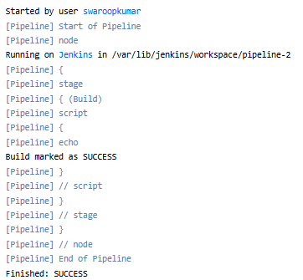

6. Setting a Stage to UNSTABLE
Sometimes a stage completes but we don't want to consider it completely successful.
For example, suppose unit tests have some failures but we want the pipeline to continue.
We can use:
unstable('Unit tests have some failures')
Example:
pipeline {
agent any

stages {

stage('Unit Test') {
steps {
script {
try {
sh 'mvn test'
} catch (Exception e) {
unstable('Unit tests failed, but continuing pipeline')
}
}
}
}

stage('Deploy') {
steps {
echo 'Deploying application...'
}
}
}
}
The pipeline can continue, but the build is marked:
UNSTABLE



7. Mark a Stage as FAILURE
If an important operation fails, we normally want the pipeline to stop.
Use:
error('Build failed')
Example:
stage('Build') {
steps {
script {
if (!fileExists('pom.xml')) {
error('pom.xml not found')
}

sh 'mvn clean package'
}
}
}
If pom.xml doesn't exist:
Build
|
+---- FAILURE
The pipeline stops at that stage.


8. catchError() for Stage Status
One of the most useful Jenkins Pipeline steps for status management is:
catchError()
It allows you to control:
- Build result
- Stage result
- Whether the pipeline continues

Example
stage('Unit Test') {
steps {
catchError(
buildResult: 'UNSTABLE',
stageResult: 'FAILURE'
) {
sh 'mvn test'
}
}
}
If the Maven test command fails:
Stage Result = FAILURE
Build Result = UNSTABLE
The pipeline can continue to the next stage.

9. Important catchError() Parameters
The syntax is:
catchError(
buildResult: 'UNSTABLE',
stageResult: 'FAILURE'
) {
// steps
}

buildResult
Controls the overall Jenkins build result.
Example:
buildResult: 'FAILURE'

stageResult
Controls the result displayed for the particular stage.
Example:
stageResult: 'FAILURE'

10. Example: Continue Pipeline After Failure
Suppose we have:
Git Checkout
↓
Build
↓
Unit Test
↓
SonarQube
↓
Deploy
We want the Unit Test stage to show FAILURE, but we want SonarQube and other stages to continue.
Use:
pipeline {
agent any

stages {

stage('Git Checkout') {
steps {
echo 'Checking out source code'
}
}

stage('Build') {
steps {
sh 'mvn clean package'
}
}

stage('Unit Test') {
steps {
catchError(
buildResult: 'UNSTABLE',
stageResult: 'FAILURE'
) {
sh 'mvn test'
}
}
}

stage('SonarQube') {
steps {
echo 'Running SonarQube analysis'
}
}

stage('Deploy') {
steps {
echo 'Deploying application'
}
}
}
}

Pipeline behavior
If Unit Test fails:
Git Checkout SUCCESS
↓
Build SUCCESS
↓
Unit Test FAILURE
↓
SonarQube SUCCESS
↓
Deploy SUCCESS
Overall build:
UNSTABLE

11. Using try-catch-finally
Another common method is standard Groovy exception handling.
stage('Build') {
steps {
script {
try {
sh 'mvn clean package'
}
catch (Exception e) {
currentBuild.result = 'FAILURE'
echo 'Build failed'
throw e
}
finally {
echo 'Build stage completed'
}
}
}
}

Flow
try
|
+-- Build successful → Continue
|
+-- Build failed
|
+-- catch
|
+-- Set FAILURE
|
+-- throw error
|
+-- finally

12. Using post Conditions
Jenkins Declarative Pipeline provides post conditions.
Common conditions:
always
success
failure
unstable
changed
aborted
unsuccessful
Example:
pipeline {
agent any

stages {

stage('Build') {
steps {
sh 'mvn clean package'
}
}
}

post {

success {
echo 'Pipeline completed successfully'
}

failure {
echo 'Pipeline failed'
}

unstable {
echo 'Pipeline is unstable'
}

always {
echo 'Pipeline execution completed'
}
}
}


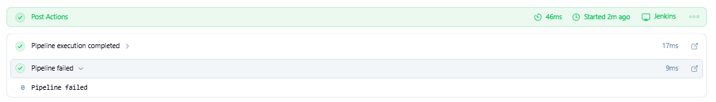

13. Stage-Level post
You can also use post directly inside a stage.
Example:
stage('Build') {

steps {
sh 'mvn clean package'
}

post {

success {
echo 'Build stage completed successfully'
}

failure {
echo 'Build stage failed'
}

always {
echo 'Build stage execution completed'
}
}
}
This is useful when you want to perform an action based on the status of a specific stage.

14. Real-Time Example: CI/CD Pipeline
A practical DevOps pipeline can look like this:
pipeline {
agent any

stages {

stage('Git Checkout') {
steps {
git branch: 'main',
url: 'https://github.com/betawins/hiring-app.git'
}

post {
success {
echo 'Git checkout successful'
}

failure {
echo 'Git checkout failed'
}
}
}

stage('Build') {
steps {
script {
if (!fileExists('pom.xml')) {
error('pom.xml not found')
}

sh 'mvn clean package'
}
}

post {
success {
echo 'Maven build successful'
}

failure {
echo 'Maven build failed'
}
}
}

stage('Unit Test') {
steps {
catchError(
buildResult: 'UNSTABLE',
stageResult: 'FAILURE'
) {
sh 'mvn test'
}
}

post {
success {
echo 'Unit tests passed'
}

failure {
echo 'Unit tests failed'
}
}
}

stage('Docker Build') {
steps {
sh 'docker build -t hiring-app:1.0 .'
}

post {
success {
echo 'Docker image created successfully'
}

failure {
echo 'Docker build failed'
}
}
}

stage('Deploy') {
steps {
echo 'Deploying application'
}

post {
success {
echo 'Deployment successful'
}

failure {
echo 'Deployment failed'
}
}
}
}

post {
success {
echo 'Complete CI/CD pipeline succeeded'
}

unstable {
echo 'CI/CD pipeline completed with warnings'
}

failure {
echo 'CI/CD pipeline failed'
}

always {
echo 'Pipeline execution completed'
}
}
}



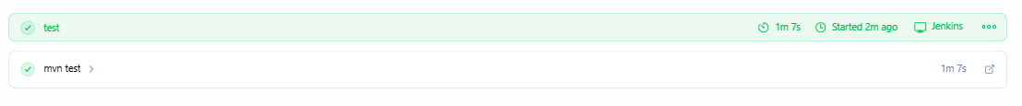

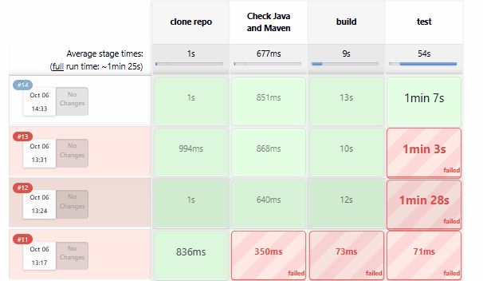

15. Stage Status vs Build Status
This distinction is important for Jenkins interviews.

Stage status
Describes the result of an individual stage.
Example:
Build SUCCESS
Unit Test FAILURE
Deploy SUCCESS

Build status
Describes the overall Jenkins Pipeline.
Example:
UNSTABLE
You can therefore have:
Stage Result:
Unit Test = FAILURE

Overall Build:
UNSTABLE
This is one of the main reasons catchError() is useful.

16. Recommended Approach
Use the following approach based on the requirement:
Requirement | Recommended Method
Normal successful/failed stage | Let Jenkins determine automatically
Stop pipeline immediately | error()
Mark build as unstable | unstable()
Continue after an error | catchError()
Execute actions after stage | Post
Custom exception handling | try/catch
Overall build status | currentBuild.result

17. Best Practices

1. Don't manually set SUCCESS unnecessarily
Normally Jenkins automatically determines success.
Avoid unnecessary:
currentBuild.result = 'SUCCESS'
when the stage has already completed successfully.

2. Use error() for critical failures
For example:
if (!fileExists('pom.xml')) {
error('pom.xml is missing')
}
This provides a clear failure reason.

3. Use catchError() when the pipeline should continue
For example:
catchError(
buildResult: 'UNSTABLE',
stageResult: 'FAILURE'
) {
sh 'mvn test'
}
This is useful when test failures should not prevent later reporting or cleanup stages.

4. Use post for notifications
For example:
post {
success {
echo 'Send success notification'
}

failure {
echo 'Send failure notification'
}
}
In a real project, this can be connected to Slack, email, Microsoft Teams, PagerDuty, etc.

18. Interview Question

Q: How do you set a stage status in Jenkins Pipeline?
Answer:
"Jenkins normally determines the stage status automatically based on the execution of the steps. If I need to control the status, I can use error() to mark a stage as failed, unstable() to mark the build as unstable, or catchError() when I want to set a specific stage result while allowing the pipeline to continue. I can also use stage-level post blocks to perform actions based on success or failure."

Example:
stage('Unit Test') {
steps {
catchError(
buildResult: 'UNSTABLE',
stageResult: 'FAILURE'
) {
sh 'mvn test'
}
}
}
This means:
Unit Test fails
↓
Stage = FAILURE
↓
Build = UNSTABLE
↓
Pipeline continues
Key takeaway: For most real-time Jenkins pipelines, use automatic status handling + error() for critical failures + catchError() for controlled failures + post for notifications and cleanup.

TASK -3 Set Stage Status in Jenkins Pipelines

Overview
Jenkins pipelines report the status of builds and build stages to indicate their success or failure. This can be handy for notifying team members about the state of the build, which reflects the stability of the code.
In some scenarios, we might need to manually set the status of a specific stage, regardless of its execution results. For example, we can have a step that runs a command that’s not critical for the overall build process. To avoid failing the whole build if this command fails, we can set the stage or build status to SUCCESS, regardless of the step result.
In this tutorial, we’re going to cover the concept of a pipeline stage in Jenkins and its different statuses. We’ll explain what each status means and how to manually set a stage status.

What Is a Pipeline Stage?
Pipeline stages represent a specific phase in the software delivery flow. For example, we can have a stage for building the application, another one for testing, and another one for deployment. These stages are linked together to form our complete pipeline.
Each of these stages contain the steps that we need to implement to achieve the goal of the stage. We can have a stage that executes some commands, copies files, or deploys an artifact. Let’s see an example of a Jenkins pipeline that has multiple stages:
pipeline{
agent any
stages{
stage("clone repo"){
steps {
git branch: "main" , url: "https://github.com/spring-projects/spring-petclinic.git"
}
}
stage('Check Java and Maven') {
steps {
sh '''
echo "JAVA_HOME=$JAVA_HOME"
echo "PATH=$PATH"

echo "Java:"
java -version

echo "Javac:"
javac -version

echo "Maven:"
mvn -version
'''
}
}
stage("build"){
steps {
sh "mvn compile"
}
}
stage("test"){
steps{
sh "mvn test"
}
}
}
}
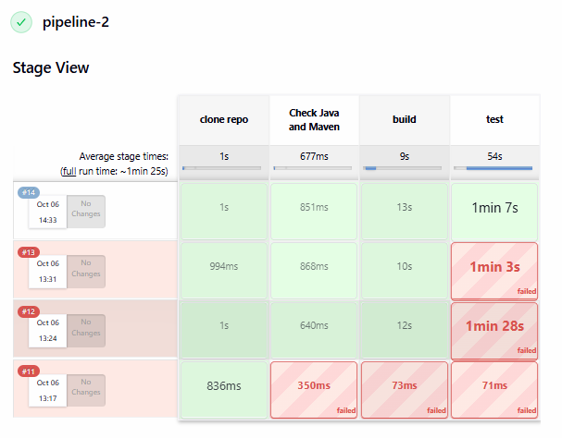
In the above code, we have a stages{} block that includes all pipeline stages inside it. Then, each stage{} block inside represents a specific phase in the application deployment. So, we first have a clone repo stage to check out the source code from GitHub, then a build stage that compiles the code, and finally, a test stage to run our tests. This structure makes it easy to understand and create a pipeline flow.

Stage Status
As the pipeline progresses and moves through the different stages, each of these stages reports its status. The stage status represents the result of executing the steps inside the stage. Let’s check the most common Jenkins stage statuses and what they represent.

3.1. SUCCESS
As the name implies, a SUCCESS status means that the steps inside the stage executed with no errors. All the steps inside the stage need to succeed in order to report the stage as SUCCESS. If these steps are executing some commands, all commands need to report a zero exit code.
For ex :
pipeline {
agent any
stages{
stage("Success")
{
steps{
sh "exit 0"
sh "ls -l"
}
}
}
}
In the above code, we have a single stage pipeline. Inside the stage, there are two steps, which are shell commands that should execute successfully. Let’s trigger the pipeline and see the results:
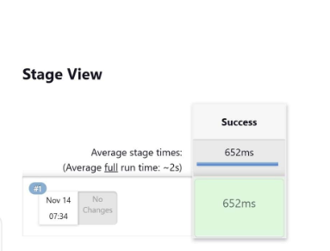

3.2. FAILED
In contrast to the SUCCESS status, a FAILED status indicates that there’s an issue with the execution of the steps inside the stage. The stage status is reported as FAILED if any of the steps inside it didn’t execute successfully. If the steps are running some commands, the stage will fail if any of the commands reports a non-zero exit code.
Let’s test this in our pipeline:

pipeline {
agent any
stages{
stage("Success"){
steps{
sh "exit 0"
sh "ls -l"
}
}
stage("Fail"){
steps{
sh "ls -l"
sh "exit 1"
}
}
}
}
Here, we added a stage to our pipeline. The new stage executes two commands, where one of them should succeed and the other should fail. Let’s trigger our pipeline:
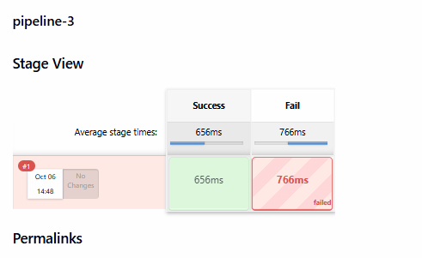
We can see here that our second stage is showing a red color, which denotes that its status is FAILED. When a stage status is FAILED, the pipeline execution will not progress to the next stage.

UNSTABLE
The UNSTABLE status reports that an error has happened, but it’s not critical to fail the stage. For example, if we want to execute a command that creates a file aside from the main pipeline flow, we wouldn’t want a failure in this command to impact the whole pipeline.
We can use a Jenkins step called warnError to produce an UNSTABLE status. warnError tries to execute the commands inside its block, and if there’s an issue, it’ll report the stage status as UNSTABLE. Let’s check this in our pipeline:
pipeline {
agent any
stages{
stage("Success"){
steps{
sh "exit 0"
sh "ls -l"
}
}
stage("Unstable"){
steps{
warnError("The command failed"){
sh "Wrong command"
}
}
}
stage("Continue execution"){
steps{
sh "exit 0"
}
}
}
}
In the above code, we added a stage with the name Unstable. Inside the stage, we use the warnError step to execute a command that should fail. Let’s trigger our pipeline:
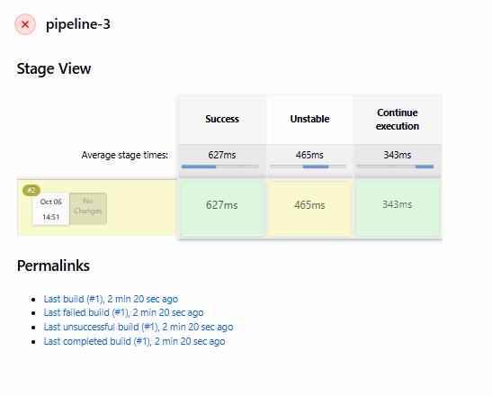
As we can see, the Unstable stage produces a yellow color, which indicates that the stage status is UNSTABLE. An important thing to note here is that the pipeline execution continued normally to the next stage. This is in contrast to the FAILED status, which stops the pipeline execution.

4. Manually Set the Stage Status
Jenkins allows us to manually set a stage status as per our needs. So, we can manipulate the default status that should be produced from a stage execution, and force a different status.
We can achieve this by using Jenkins’ catchError step. The catchError step tries to execute the commands inside its block, and we provide it with a specific stage and build status to set in case the commands fail.
Let’s try this in our pipeline:
pipeline {
agent any
stages{
stage("Success"){
steps{
sh "exit 0"
sh "ls -l"
}
}
stage("Set Stage Status"){
steps{
catchError(buildResult: 'SUCCESS', stageResult: 'SUCCESS') {
sh "exit 1"
}
}
}
stage("Continue execution"){
steps{
sh "exit 0"
}
}
}
}
Here, we use the catchError step to execute a command, and if the command fails, we’ll set the stage and build status to SUCCESS. Let’s trigger our pipeline:
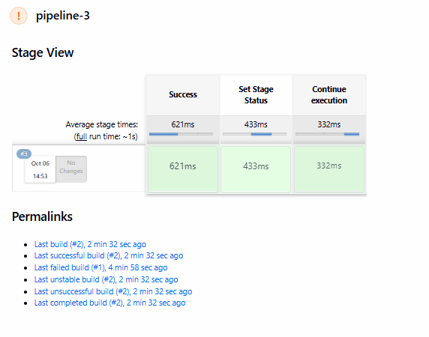

We can also set other statuses, like the UNSTABLE status:
pipeline{
agent any
stages{
stage("Success"){
steps{
sh "exit 0"
sh "ls -l"
}
}
stage("Set Stage Status"){
steps{
catchError(buildResult: 'UNSTABLE', stageResult: 'UNSTABLE') {
sh "exit 1"
}
}
}
stage("Continue execution"){
steps{
sh "exit 0"
}
}
}
}Copy
Here, we have the same code, but we changed the status in the catchError step from SUCCESS to UNSTABLE. Let’s trigger our pipeline again:

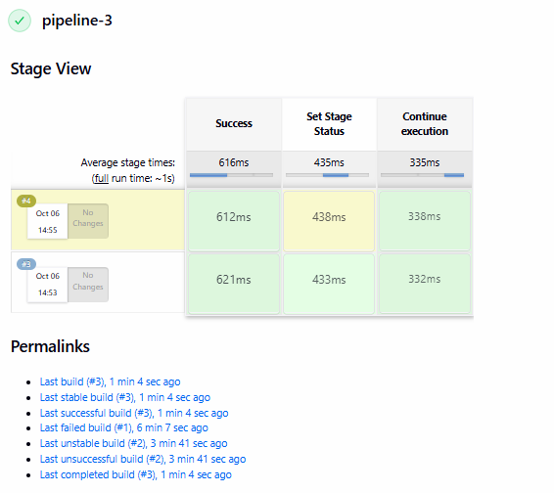

5. Conclusion
In this article, we showed how to manually set a stage status in Jenkins. We explained the concept of a pipeline stage, which represents a specific phase in the software delivery.
We covered the different statuses for a stage and what each of them indicate, including SUCCESS, FAILED, or UNSTABLE. Finally, we manipulated the pipeline code using the catchError step to set the stage status, regardless of its execution results.

TASK-4 Return Stdout, Stderr, and Status From Jenkins sh Script

1. Overview
Jenkins pipeline provides a flexible structure where we can integrate with many other tools and platforms to execute our workflow. One common example for this is when we need to run native operating system commands. Jenkins provides an easy syntax to write our commands inline with our pipeline code.
In this tutorial, we’re going to explain the fundamentals of Linux standard streams and how they relate to the shell commands. We’ll show how to execute our commands inside a Jenkins pipeline and return the output of these streams to the pipeline code.

2. What Are Stdout, Stderr, and Status Codes
Linux standard streams are communication channels that connect a program to its environment. They provide a means of transferring data to and from this program. The stdout and stderr are types of these standard streams.
Status codes are numerical values produced as a result of executing commands or programs to indicate whether the execution was successful or not.
Let’s check how each of these work.

2.1. Standard Output
The standard output stream, or stdout, is responsible for capturing the output that comes from a command execution. It’s usually connected to the terminal and sends the output from this command to be displayed on the terminal. For example, when we use echo, it’s actually connected to the stdout:
$ echo "this is coming from stdout"
this is coming from stdoutCopy
Here, the stdout captured the message from echo and sent it to the terminal.

2.2. Standard Error
Standard error, or stderr, is also an output stream, but the difference is that it captures the errors produced from a command execution. So when a command fails, the error message is sent to the stderr stream, which usually also sends it to the terminal:
$ ls noSuchFile
ls: cannot access 'noSuchFile': No such file or directoryCopy
Here we’re trying to list a file that doesn’t exist, so an error message is displayed. This message is actually captured from the command by stderr, which sent it to the terminal.

2.3. Status Code
When a command or a program finishes, it needs a way to report if its execution was successful or not. This way is the status code, or exit code. It’s simply a number between 0 and 255 that represents the execution status. A zero status code means success, and any non-zero code means failure.
To check the status code of a command, we use the $? special variable. This variable displays the status code of the last executed command:
$ echo "this is a successful command"
this is a successful command
$ echo $?
0
$ ls unsuccessful
ls: cannot access 'unsuccessful': No such file or directory
$ echo $?
2Copy
In the above snippet, the first echo command was successful, so when we printed the $? variable, we got a zero status code. However, after the ls command failed, the $? variable printed 2, which is a non-zero code.

3. Using the Jenkins sh Step
We can use Jenkins to execute native operating system commands as part of our pipeline code. To achieve this on Linux, we use the sh step. The sh step takes a command and executes it on the agent node where the pipeline is running.
Let’s check this with an example:
pipeline {
agent any
stages {
stage("use Linux commands"){
steps {
script {
sh "echo successful command"
sh "ls noSuchFile"
}
}
}
}
}
In the above snippet, we have a pipeline code that executes two Linux commands. The first command is echo, which should complete successfully, and the other is ls, which should fail.
Now, if we run our pipeline, we should see the output in the console logs:
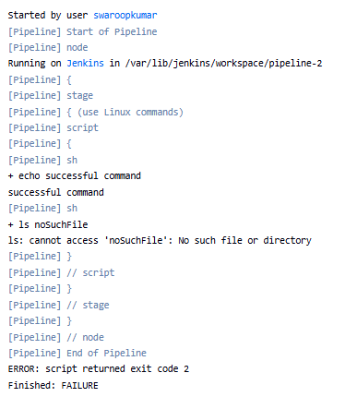
As we can see, the two commands produced the expected output in the pipeline logs. We can also note that the exit code of the failed command is shown at the end of the pipeline. In other words, the stdout, stderr, and status code are displayed in the logs.

4. Returning Stdout, Stderr, and Status From sh Script
Instead of just printing the standard streams and status code to the console logs, we can make more use of them. For example, we might save their values in a pipeline variable to further control the pipeline flow. In order to do this, we need to return their values from the sh step.

4.1. Return the Stdout
To return the stdout of a command, the sh step provides a longer format that contains a returnStdout flag. We can set this flag to return the stdout:
pipeline {
agent any
stages {
stage("use Linux commands"){
steps {
script {
def stdout = sh script: "echo returned output", returnStdout: true
print "The stdout is:\n ${stdout}"
}
}
}
}
}
Here, we passed two parameters to the sh step: the script parameter, which contains the command, and returnStdout, which returns the stdout of the command. Finally, we print the variable in which we saved the return value.
Let’s run our pipeline:
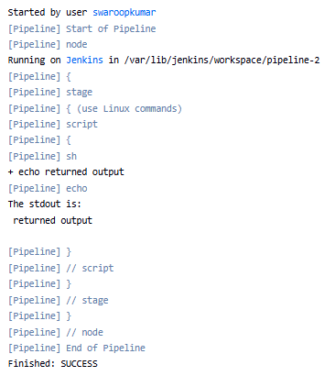

4.2. Return the Status Code
The sh step also has a returnStatus flag for returning the status code of a command. We can set this flag to get the status code value:
pipeline {
agent any
stages {
stage("use Linux commands"){
steps {
script {
def status = sh script: "echo returned output", returnStatus: true
print "The status code is:\n ${status}"
status = sh script: "ls noSuchFile", returnStatus: true
print "The status code is:\n ${status}"
}
}
}
}
}
In the above snippet, we used the sh step twice: once for a successful command, and a second time for a command that will fail. In both commands, we return the status code using the returnStdout flag into a variable that we print.
Let’s check the output of the pipeline:
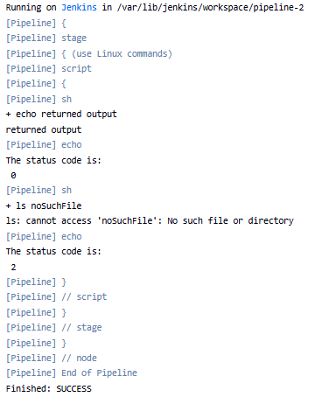
We can see that after the first successful echo command, the variable value was 0. However, as the ls command failed, the variable value was 2.

4.3. Return the Stderr
There’s no explicit flag in the sh step for returning the stderr; however, we can manipulate our command by using file descriptors. File descriptors are numbers that represent the contents of a data stream. So, we can get the number that represents the stderr and redirect its contents to the stdout.
The file descriptors for stderr and stdout are reserved. The numbers 1 and 2 are associated with stdout and stderr, respectively. Let’s check how we can make use of this in our pipeline:
pipeline {
agent any
stages{
stage("use Linux commands"){
steps{
script{
def stderr = sh script:"ls noSuchFile 2>&1 || true", returnStdout: true
print "The stderr is:\n ${stderr}"
}
}
}
}
}
Let’s break down the above snippet. First, we use an ls command that will fail in order to get the error message into stderr. After that, we use 2>$1 to redirect the stderr file descriptor to the stdout file descriptor. The || true is to force the command to exit with success in order not to abort the pipeline. Finally, we return the stdout, which now contains the stderr contents.
Let’s run our pipeline:
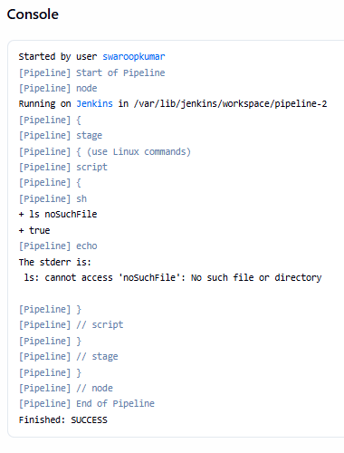
So, as we can see, our variable displayed the error message from the stderr, which returned from the sh step through the stdout.

4.4. Return Both in a Single Step
We can also return stdout or stderr, along with their status code, in a single command. This removes the repetition and makes the code cleaner.
Let’s manipulate our stdout example command:
pipeline {
agent any
stages{
stage("use Linux commands"){
steps{
script{
def stdout_status = sh script:'echo "this is stdout" && echo "$?" ', returnStdout: true
print "The stdout and status is:\n ${stdout_status}"
}
}
}
}
}
Again we use the returnStdout flag from the sh step. The && operator will merge the output from both echo commands into the stdout. So, we’ll have our output message along with the status code returned:
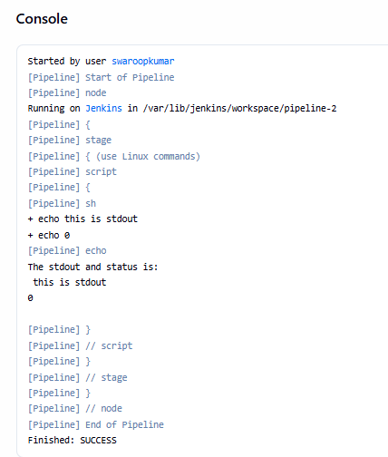
As we can see here, the variable contained both the stdout and the status code.
And we can do the same with the stderr:
pipeline {
agent any
stages{
stage("use Linux commands"){
steps{
script{
def stderr_status = sh script:'ls noSuchFile 2>&1 || true && echo "$?" ', returnStdout: true
print "The stderr and status is:\n ${stderr_status}"
}
}
}
}
}
In the above snippet, we redirected the file descriptor of the stderr to the stdout and also used the || true to force a successful exit. Now, the stdout should contain the stderr and the status code:
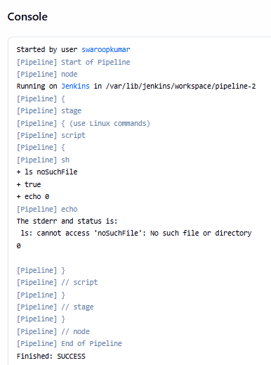

TASK-5 Updating Jenkins Plugins From the Command Line

1. Overview
Jenkins has a powerful plugin management system. We may occasionally need to update a plugin using the Jenkins Dashboard when a new version of the plugin is available. However, updating plugins from the command line is useful for administrators to automate tasks.
In this tutorial, we’ll discuss how to update Jenkins plugins from the command line. After a brief discussion of the Jenkins CLI (Command-Line Interface), we’ll first learn the Jenkins CLI’s install-plugin command. Then, we’ll see how to use the groovy command of the Jenkins CLI.
The version of Jenkins we use is 2.452.3. Jenkins is running on localhost on port 8080. We need administrator rights in Jenkins to update plugins.

2. The Jenkins CLI
Jenkins provides a CLI to access Jenkins from a script or command line. This built-in CLI is known as the Jenkins CLI. It’s useful for automating routine tasks.
The jenkins-cli.jar jar file allows us to access the Jenkins CLI. We can download it from the Jenkins CLI view of the Manage Jenkins page in the Jenkins UI.
There are several commands of the Jenkins CLI. For example, the list-plugins command lists the installed Jenkins plugins. We’ll use the install-plugin and groovy commands to update Jenkins plugins.

3. Using the install-plugin Command
In this section, we’ll first get the list of plugins needing updating and then update those plugins using install-plugin.

3.1. Getting the List of Plugins
After downloading and moving the jenkins-cli.jar file to the current directory, let’s first list the installed plugins by running the java -jar command:
$ java -jar jenkins-cli.jar -s http://localhost:8080 -auth admin:admin_secret_password list-plugins
ant Ant Plugin 497.v94e7d9fffa_b_9 (511.v0a_a_1a_334f41b_)
antisamy-markup-formatter OWASP Markup Formatter Plugin 162.v0e6ec0fcfcf6
apache-httpcomponents-client-4-api Apache HttpComponents Client 4.x API Plugin 4.5.14-208.v438351942757
...
The remaining options and commands after java -jar jenkins-cli.jar belong to jenkins-cli.jar. We pass the address of the Jenkins controller using the -s option, which is http://localhost:8080. The -auth option specifies the Jenkins username and password. So, we pass admin and admin_secret_password as the username and password. The list-plugins command of the Jenkins CLI lists the installed plugins.
We abbreviated the output to list only the first three plugins. The list consists of three columns. The first two columns contain the short and long names of the plugins, and the last column contains the version of each plugin.

API NEW TOKEN :
Cli token : 111f70fab120b455cb87eb57e8800b4b31
The plugin at the top of the list is the Ant Plugin. Notably, there are two items in the last column. The first one, 497.v94e7d9fffa_b_9, is the currently installed plugin’s version. If there’s a newer version of a plugin, it’s shown in parentheses. According to the output, there’s a newer version of the Ant Plugin, 511.v0a_a_1a_334f41b_.
Let’s get the names of the plugins needing update by filtering the output:

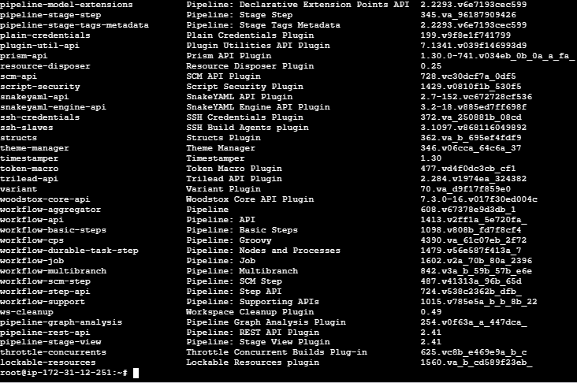

3.2. Updating the Plugins
Now, let’s install the plugins stored in the update_list variable together with their dependencies. For this purpose, let’s use the install-plugin command of the Jenkins CLI:
$ java -jar jenkins-cli.jar -s http://localhost:8080 -auth admin: admin_secret_password install-plugin $update_list -restart
Installing ant from update center
Installing commons-lang3-api from update center
Installing echarts-api from update center
...
Copy
The plugins are installed one after the other. Upon successful installation, the -restart option restarts Jenkins. The installed plugins take effect after we restart Jenkins.
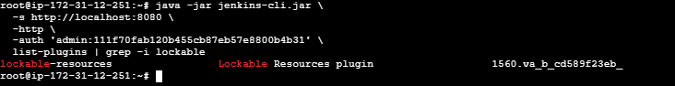

Let’s list the plugins needing update once more after the installation:
$ java -jar jenkins-cli.jar -s http://localhost:8080 -auth admin:admin_secret_password list-plugins | grep ")$" | awk '{print $1}'Copy
Since we updated all plugins, we should not see any newer versions to update.

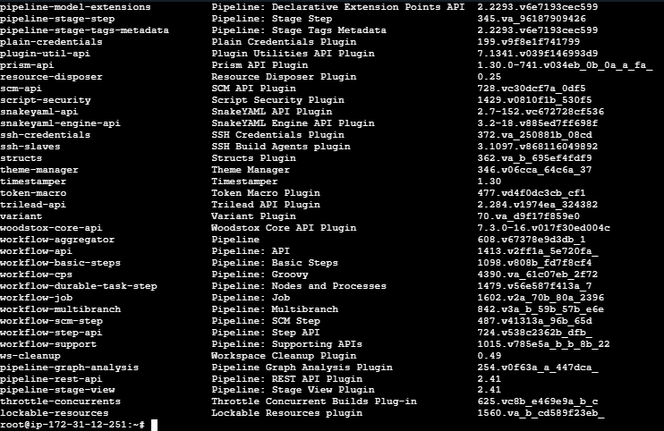

Using the groovy Command
Another way to update plugins using the Jenkins CLI is to use the groovy command, which runs Groovy scripts.
Let’s run a Groovy script, update_plugins.groovy, that updates plugins:
$ java -jar jenkins-cli.jar -s http://localhost:8080 -auth admin: admin_secret_password groovy = < update_plugins.groovyCopy
It’s the groovy = < update_plugins.groovy part that’s important for us. Here, the groovy command runs the update_plugins.groovy script. = < between the groovy command and update_plugins.groovy feeds the contents of the script to the Jenkins CLI using stdin.
Let’s now see what we do within the update_plugins.groovy script:
$ cat update_plugins.groovy
import jenkins.model.*

def plugins = Jenkins.instance.pluginManager.plugins.findAll {
it -> it.hasUpdate()
}.collect {
it -> it.getShortName()
}

Jenkins.instance.pluginManager.install(plugins, false).each{ it -> it.get() }

Jenkins.instance.safeRestart()Copy
Firstly, we need to import the jenkins.model package using import jenkins.model.*.
Secondly, we find all the plugins with newer versions using Jenkins.instance.pluginManager.plugins.findAll { it -> it.hasUpdate() }. It returns a Groovy List. Then, we obtain another list by invoking the collect() method of this list using collect{ it -> it.getShortName() }. After that, we assign the returned list by collect() to the plugins variable, which contains the name of the plugins to be updated.
Then, calling Jenkins.instance.pluginManager.install(plugins, false).each{ it -> it.get() } updates the plugins stored in the plugins variable one after the other.
Finally, we restart Jenkins using Jenkins.instance.safeRestart().
Let’s list the plugins needing update after running the script:
$ java -jar jenkins-cli.jar -s http://localhost:8080 -auth admin:admin_secret_password list-plugins | grep ")$" | awk '{print $1}'Copy
As expected, everything is up to date.
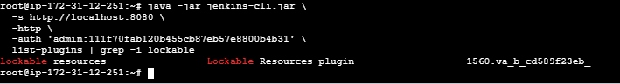

5. Conclusion
In this article, we discussed how to update Jenkins plugins from the command line. Firstly, we learned that the Jenkins CLI allowed users to access Jenkins from the command line. Therefore, it’s useful for automating tasks, updates, and troubleshooting using scripts.
Then, we saw that we could use the Jenkins CLI’s install-plugin command as the first option. We obtained the list of plugins needing update by filtering the output of the list-plugins command. We can automate plugin updates using a script in this option.
Finally, we learned that the Jenkins CLI’s groovy command was the second alternative. We used a Groovy script to update the plugins. Therefore, we can automate plugin updates by running the Groovy script from a shell script.

TASK-6 Jenkins Pipeline Clean Workspace After Each Build

1. Overview
Jenkins workspace is a storage location where a build stores its related files. It is used by successive builds of the same job so we might need to clean it up frequently to avoid conflicting files or output artifacts.
In this tutorial, we’ll cover different ways that we can clean up the workspace of a Jenkins job.

2. What’s a Jenkins Workspace
Jenkins workspace is a directory created on the node where a job is executing. It stores files related to a running build like source code, output artifacts, or a Dockerfile. It is the storage space that the build uses to execute different tasks.
Each job has a separate workspace on the Jenkins node. The path to the workspace directory follows the job name structure. For example, if we created a job with the name test-job under a folder name test-folder, then the workspace directory will be /{Jenkins root directory on the node}/workspace/test-folder/test-job:

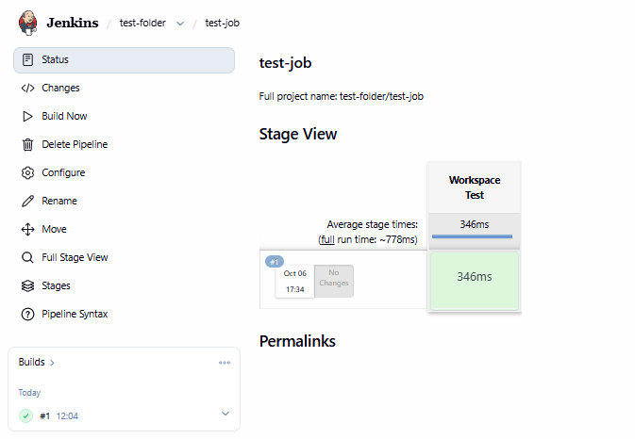

$ pwd
/var/lib/jenkins/workspace
$ ls
test-folder
$ cd test-folder/
$ ls
test-job
$ cd test-job/
$ pwd
/var/lib/jenkins/workspace/test-folder/test-job
In this example, the Jenkins root directory on the node is /var/lib/jenkins. So as we can see, the path of the workspace is /var/lib/jenkins/workspace/test-folder/test-job.
Now lets create a job
pipeline {
agent any
stages {
stage("create file"){
steps{
script {
sh "touch myfile.txt"
}
}
}
}
}
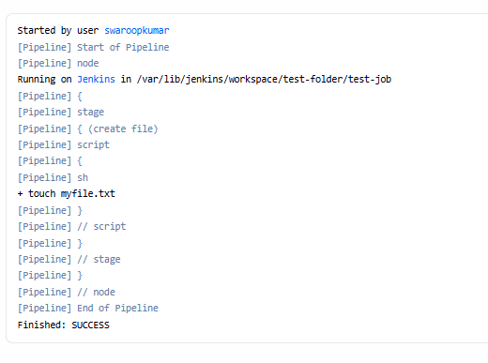

If we trigger our job and check the workspace now we should see the file there:
$ pwd
/var/lib/jenkins/workspace/test-folder/test-job
$ ls
myfile.txt

So now we can work with files and persist data to our workspace from our job.

Cleaning the Workspace Using deleteDir Step
The first method to clean the workspace directory is to use the deleteDir step. The deleteDir is part of the workflow basic steps plugin which probably comes installed by default so we don’t need to install it. When we add the deleteDir step to our job it removes any files from the current directory. So if we’re running the stage in the default workspace directory it will clean it up:
stage("clean workspace") {
steps {
script {
sh "ls"
deleteDir()
sh "ls"
}
}
}
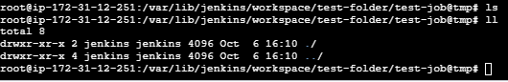
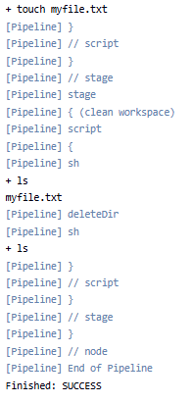
Here we added another stage to our previous job. We list the contents of the workspace using the ls command before and after the deleteDir() step to see the difference.
Now let’s trigger the job and check the output:
...
+ touch myfile.txt
[Pipeline] sh
+ ls
myfile.txt
[Pipeline] deleteDir
[Pipeline] sh
+ ls
...Copy
As we can see, the first ls command shows the file in the workspace, however, the second ls command after the deleteDir step is showing no content.

4. Cleaning the Workspace Using cleanWs Step
Another simple method to clean the workspace directory is by using the cleanWs step. The cleanWs is part of the workspace cleanup plugin. We’ll need to install this plugin manually before using the step.
We can install this plugin from the Jenkins available plugins menu:
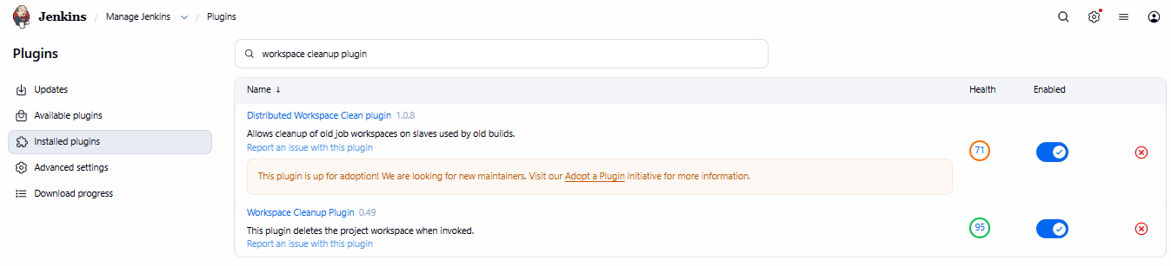
After installing the plugin, we can start using the cleanWs step in the job.
In our example, we’ll replace the previous deleteDir step with the cleanWs step:
stage("clean workspace") {
steps {
script {
sh "ls"
cleanWs()
sh "ls"
}
}
}
Now let’s check the output of the job:
...
+ touch myfile.txt
[Pipeline] sh
+ ls
myfile.txt
[Pipeline] cleanWs
[Pipeline] sh
+ ls
...
Again we can see the same results as the previous example. The first ls command shows the file in the workspace, while the second ls command after the cleanWs step shows no content.

5. Cleaning the Workspace Using rm Command
One of the very handy options of Jenkins is that you can use the native commands of the node operating system inside the job. For example, if you’re executing the job on a Linux node you can use bash shell commands, or if it’s a Windows node you can use batch commands.
So in our example, if we don’t prefer using plugins we can simply use the Linux rm command to clean the workspace directory:
stage("clean workspace") {
steps {
script {
sh "ls"
sh "rm *"
sh "ls"
}
}
}Copy
Here we used the * wildcard to match any files in the workspace, but we can manipulate the command options as we want.
Now let’s trigger our job and see the results:
...
+ touch myfile.txt
[Pipeline] sh
+ ls
myfile.txt
[Pipeline] sh
+ rm myfile.txt
[Pipeline] sh
+ ls
...Copy
As we can see, the file in the workspace appears after the first ls command and it was removed by the rm command and the workspace is showing no content.

6. Conclusion
In this article, we’ve covered the basics of Jenkins workspace and how to clean its storage.
The Jenkins workspace is a directory on the node that stores files related to a job. Because the workspace is used by successive builds of the same job, we might need to clean it up to avoid any conflict in the stored files.
We can clean up the workspace by using the deleteDir step, which removes the contents of the current directory. Another method to clean up the workspace is by using the cleanWs step, which checks the workspace of the job and deletes data inside it. Finally, if we don’t prefer using plugins we can use the native Linux rm command to delete files in the workspace.

TASK-6 Create JSON Strings via Groovy Variables in Jenkins Pipeline

1. Overview
Serialization is a crucial concept when working with objects in any programming language. It’s the process of converting objects to a byte stream with a standard format that can be stored and transferred. This enables us to save the state of an object, transmit it, and reconstruct it again in a different destination system.
In this tutorial, we’ll cover how to serialize Groovy objects to a JSON string inside Jenkins pipeline.

2. Creating Groovy Object in Jenkins
Jenkins enables us to use native Groovy language scripts inside pipelines. This feature provides great flexibility to customize the pipeline flow and implement more complex scenarios. We can use the Groovy language in scripted pipelines or declarative pipelines inside a script block.
By using the Groovy language, we can create primitive data types and objects in our pipelines:

pipeline {
agent any
stages{
stage("create groovy variable"){
steps{
script{
def student = ["name":"John", "age":20, "subjects":["English", "Math", "Physics"]]
echo "The variable type is ${student.getClass()}"
echo "The student name is ${student.name}"
echo "The student age is ${student.age}"
echo "The first subject is ${student.subjects[0]}"
}
}
}
}
}
Here we created a variable with the name student and a type of map, and we provided some key/value pairs for it. Then we print the class type of the variable using the getClass() method and print some of its values. Now let’s trigger our pipeline and see the output
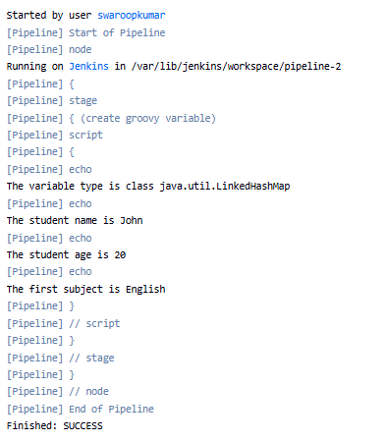
As we can see, the variable class type is LinkedHashMap which is an implementation of the map interface. Then we can see the values that we defined in our map. So this is how we can simply define and work with Groovy variables inside a Jenkins pipeline.

3. Creating JSON Strings Using JsonOutput Class
Now if we want to convert our variable into a JSON string, we can use the native Groovy JsonOutput. The JsonOutput is a class for serializing Groovy objects to JSON strings. It’s part of the groovy.json package which contains different classes required for working with JSON.
The JsonOutput class contains a static toJson() method which takes a Groovy object as a parameter and returns a JSON string. So, let’s try this on our previous variable in the pipeline:
import groovy.json.JsonOutput
pipeline {
agent any
stages{
stage("serialize groovy variable"){
steps{
script{
def student = ["name":"John", "age":20, "subjects":["English", "Math", "Physics"]]
def json_string = JsonOutput.toJson(student)
def json_pretty = JsonOutput.prettyPrint(json_string)
echo "${json_pretty}"
}
}
}

}
}
Here we first imported the JsonOutput class to use it in our script. Then we used the toJson() method and passed the student variable as a parameter. Finally, we formatted the JSON output using the prettyPrint() method to make it easier to read.
Now let’s check the output of this pipeline:
[Pipeline] echo
{
"name": "John",
"age": 20,
"subjects": [
"English",
"Math",
"Physics"
]
}
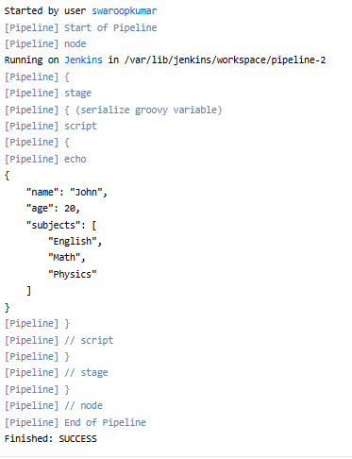

4. Creating JSON Strings Using writeJSON Step
Another method to serialize a Groovy object into a JSON string is by using the writeJSON step. This is a native Jenkins step that we can use instead of relying on the groovy.json package or any of its classes. writeJSON is part of the pipeline utility steps plugin, so we need to install this plugin first to use this step:
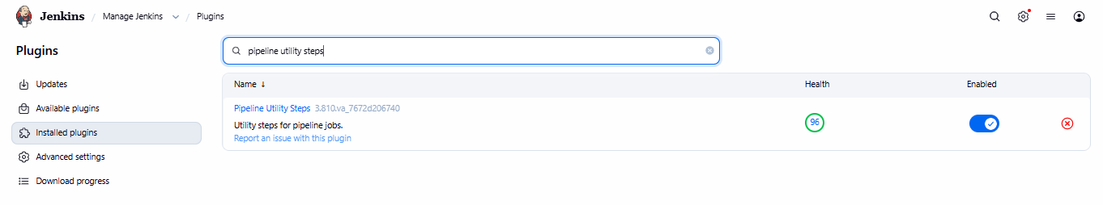
After installing the plugin, we can use the writeJSON step inside the pipeline script to serialize our variable:
pipeline {
agent any
stages{
stage("serialize groovy variable"){
steps{
script{
def student = ["name":"John", "age":20, "subjects":["English", "Math", "Physics"]]
def json_pretty = writeJSON(json: student, returnText: true, pretty: 4)
echo "${json_pretty}"
}
}
}

}
}
As we can see, the writeJSON step takes some parameters. The json parameter takes the name of the object that we need to convert to a JSON string, in this example, it’s the student variable. The returnText is a boolean that returns the JSON string as an output from the step instead of writing it to a file. The pretty parameter formats the output with the specified number of spaces for each indentation.
Now let’s check the output of this pipeline script:
[Pipeline] echo
{
"name": "John",
"age": 20,
"subjects": [
"English",
"Math",
"Physics"
]
}

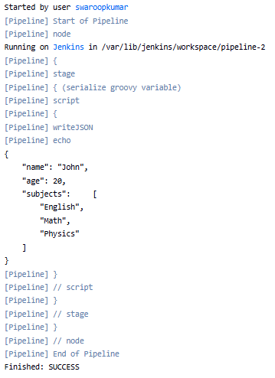
Again we can see the output is similar to the one we had when using the JsonOutput class. The writeJSON step converted the student variable into a JSON string with its state and values.

5. Conclusion
Serialization is a common process that we use to convert objects into a byte stream format. It enables us to store, transmit, and reconstruct the object’s state. Using Jenkins, we can define objects and variables in Groovy language inside pipelines.
In this article, we learned how to serialize these objects to JSON strings using the Groovy JsonOutput class, which we can import into our code. We can also use the native writeJSON step in Jenkins, which does the same thing, without relying on the Groovy packages and classes.

TASK-7 Fixing Jenkins “Pipeline sh bad substitution” Error

1. Introduction
Jenkins is a cornerstone tool in continuous integration and continuous deployment (CI/CD). It allows us to automate various stages of our software development lifecycle. However, as with any powerful tool, Jenkins is not without its quirks. One such common issue is the “Pipeline sh bad substitution” error encountered in Jenkins pipelines. This error can be frustrating, especially when it halts the progress of automated builds and deployments.
In this tutorial, we’ll look into the “bad substitution” error in Jenkins, understand why it occurs, and explore multiple solutions to resolve it. We’ll provide practical examples and tips to help us avoid this error in our Jenkins pipelines, ensuring smoother automation and more reliable builds. Let’s get started!

2. Understanding the “bad substitution” Error
The “bad substitution” error in Jenkins usually occurs when there’s a mismatch between the shell syntax and how Jenkins interprets variables. This error is often seen in the context of shell (sh) steps within a Jenkins pipeline script.
Let’s see a quick pipeline code where this error might arise:
sh 'curl -v --user user:password --data-binary ${buildDir}package${env.BUILD_NUMBER}.tar -X
PUT "http://artifactory.mydomain.com/artifactory/release-packages/package${env.BUILD_NUMBER}.tar"'Copy
In this example, the sh step attempts to use the env.BUILD_NUMBER variable. However, if not handled correctly, Jenkins throws a “bad substitution” error. This error generally means that the shell script is trying to substitute a variable in a way unsupported by the default shell (sh).
Here are some common causes of this error:
- Incorrect quotation marks: Mixing single and double quotes improperly can lead to this issue
- Shell discrepancies: Using sh instead of bash can cause compatibility issues with a certain syntax
- Variable scope and syntax: Incorrect usage of environment variables and their syntax can result in substitution errors
When this error occurs, it can significantly impact pipeline execution. The affected stage will fail, potentially halting the entire pipeline and preventing subsequent stages from running. This can lead to delayed deployments, interrupted workflows, and considerable troubleshooting time.

3. Practical Description
Let’s assume we have a Jenkins pipeline that uploads a .tar file to an Artifactory server. The pipeline uses the build number to name the file dynamically.
Here is what our pipeline script might look like:
pipeline {
agent any
environment {
buildDir = "/var/lib/jenkins/workspace/Package_Deploy_Pipeline/"
}
stages {
stage('Upload') {
steps {
sh 'curl -v --user user:password --data-binary ${buildDir}package${env.BUILD_NUMBER}.tar -X
PUT "http://artifactory.mydomain.com/artifactory/release-packages/package${env.BUILD_NUMBER}.tar"'
}
}
}
}

In this script, we use ${env.BUILD_NUMBER} to dynamically include the Jenkins build number in the filename. However, this often leads to a “bad substitution” error because of how the shell interprets the variables.
When the script runs, Jenkins throws the following error:
[Pipeline] sh
[Package_Deploy_Pipeline] Running shell script
/var/lib/jenkins/workspace/Package_Deploy_Pipeline@tmp/durable-4c8b7958/script.sh:
2: /var/lib/jenkins/workspace/Package_Deploy_Pipeline@tmp/durable-4c8b7958/script.sh:
Bad substitution
[Pipeline] } //node
[Pipeline] Allocate node : End
[Pipeline] End of Pipeline
ERROR: script returned exit code 2
Copy
Interestingly, if we hardcode the build number, the script works without any issues:
sh 'curl -v --user user:password --data-binary ${buildDir}package113.tar -X
PUT "http://artifactory.mydomain.com/artifactory/release-packages/package113.tar"'

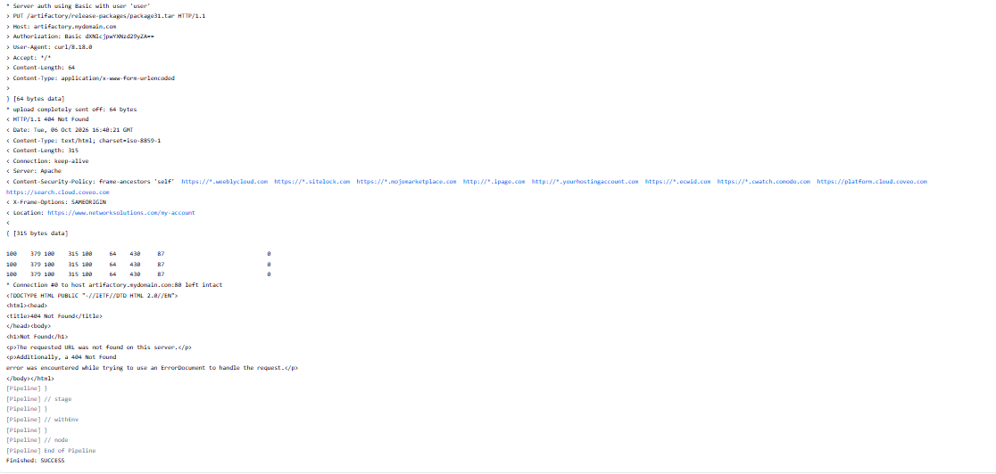
This scenario highlights the problem with variable substitution in the shell script. Understanding this specific issue helps us pinpoint the solution more effectively.

4. Diagnosing the Issue
To effectively resolve the “bad substitution” error, we need to systematically diagnose the problem and identify the root cause.
First, we should ensure that we can consistently reproduce the error. To do this, we should use a simplified version of our pipeline script to isolate the issue.
Let’s see a simplified example of our pipeline script for proper diagnosis:
pipeline {
agent any
environment {
buildDir = "/var/lib/jenkins/workspace/Package_Deploy_Pipeline/"
}
stages {
stage('Test') {
steps {
sh 'echo ${env.BUILD_NUMBER}'
}
}
}
}

Jenkins pipelines are written in Groovy, which adds another layer of complexity when interacting with shell commands. If not handled correctly, Groovy’s string handling can interfere with the shell’s variable substitution.
In our scenario, we should run this script and verify that it produces the “bad substitution” error. If it does, we’ve successfully isolated the problem.
After reproducing the error, we should examine the shell script syntax within the sh step. The most common cause of the “bad substitution” error is the incorrect usage of quotation marks. When using single quotes (‘), the shell interprets everything literally and does not perform variable substitution.
After isolating the problem and identifying the root cause as single quotes, let’s now discuss multiple ways to fix the issue.

5. Using Double Quotes for Variable Substitution
One straightforward solution is to use double quotes (“) for variable interpolation in the shell script. This ensures that the shell correctly substitutes the variables.
Let’s see how we can modify our sample pipeline script to make use of double quotes:
pipeline {
agent any
environment {
buildDir = "/var/lib/jenkins/workspace/Package_Deploy_Pipeline/"
}
stages {
stage('Upload') {
steps {
sh "curl -v --user user:password
--data-binary ${buildDir}package${env.BUILD_NUMBER}.tar -X
PUT \"http://artifactory.mydomain.com/artifactory/release-packages/package${env.BUILD_NUMBER}.tar\""
}
}
}
}
In this example, we wrap the entire sh command in double quotes. This allows for the proper interpolation of ${env.BUILD_NUMBER} and other variables.
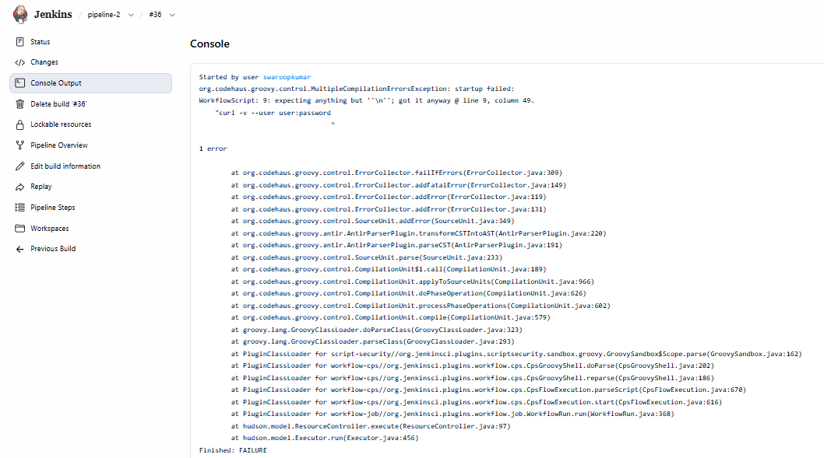

This method is simple, straightforward, and easy to understand and implement.
On the other hand, it may lead to complex escaping if the command itself contains double quotes. There is also limited flexibility in handling more complex scripts.

6. Using Triple Quotes for Groovy String Interpolation
Another effective solution is to use triple double quotes (“””) for Groovy string interpolation. This method allows for cleaner handling of complex strings and reduces the need for escaping characters.
Let’s see how we can modify our sample pipeline script using triple-double quotes:
pipeline {
agent any
environment {
buildDir = "/var/lib/jenkins/workspace/Package_Deploy_Pipeline/"
}
stages {
stage('Upload') {
steps {
sh """curl -v --user user:password
--data-binary ${buildDir}package${env.BUILD_NUMBER}.tar -X PUT "http://artifactory.mydomain.com/artifactory/release-packages/package${env.BUILD_NUMBER}.tar""""
}
}
}
}

Here, using triple quotes simplifies handling complex strings and avoids many common pitfalls associated with single and double quotes.
This approach is beneficial when dealing with long or complex shell commands and when the shell command contains multiple nested quotes. It helps to improve the pipeline script’s readability and maintainability. In short, we have cleaner and more readable code while reducing the need for escaping characters.
Contrastingly, this method has a slightly more complex syntax that may not be immediately familiar to all users.

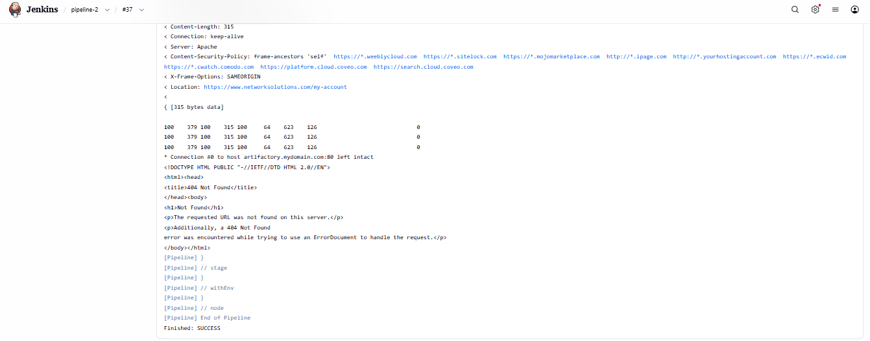

7. Ensuring Correct Shell Usage
The shell (sh) used in the pipeline can also influence the occurrence of the “bad substitution” error. By default, Jenkins uses the sh shell, which may not support certain script syntax. Explicitly specifying the Bash shell can resolve these issues.
Let’s see an example of how to modify our script to use the Bash shell:
pipeline {
agent any
environment {
buildDir = "/var/lib/jenkins/workspace/Package_Deploy_Pipeline/"
}
stages {
stage('Upload') {
steps {
sh '''#!/bin/bash -xe
curl -v --user user:password
--data-binary ${buildDir}package${env.BUILD_NUMBER}.tar -X PUT "http://artifactory.mydomain.com/artifactory/release-packages/package${env.BUILD_NUMBER}.tar"'''
}
}
}
}

By adding #!/bin/bash -xe at the beginning of the sh command, we ensure that Bash interprets the script, which supports more complex syntax and variable substitution. This ensures compatibility with Bash-specific features and syntax and reduces the risk of encountering “bad substitution” errors due to shell discrepancies.
Lastly, it provides better debugging capabilities with the -xe options. This gives us greater control over the shell environment with improved compatibility and debugging.
However, it can be a slightly more complex setup, requiring familiarity with shell scripting and shebang usage.
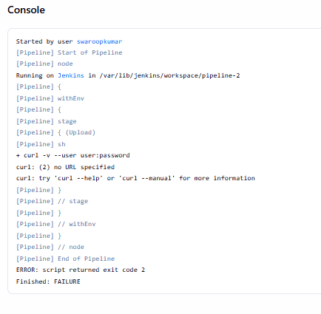

8. Using withEnv for Environment Variables
Another robust method to handle environment variables in Jenkins pipelines is to use the withEnv block. This approach explicitly defines environment variables within the pipeline, ensuring they are correctly recognized and substituted in the shell scripts.
Let’s see an example of using the withEnv block to avoid the “bad substitution” error:
pipeline {
agent any
environment {
buildDir = "/var/lib/jenkins/workspace/Package_Deploy_Pipeline/"
}
stages {
stage('Upload') {
steps {
withEnv(["BUILD_NUMBER=${env.BUILD_NUMBER}"]) {
sh '''#!/bin/bash -xe
curl -v --user user:password
--data-binary ${buildDir}package${BUILD_NUMBER}.tar -X PUT "http://artifactory.mydomain.com/artifactory/release-packages/package${BUILD_NUMBER}.tar"'''
}
}
}
}
}

In this script, the withEnv block ensures that BUILD_NUMBER is correctly exported to the shell environment, allowing for proper substitution in the shell script.
With this method, we have explicit environment control by defining which environment variables are available to the shell script. Also, substitution errors are reduced by ensuring variables are properly exported. Lastly, this method is flexible as it can be combined with other methods for greater environmental control.
On the other hand, its syntax is slightly more complex as it requires additional configuration for each environment variable.

9. Combining Different Techniques
In some cases, we may need to combine different techniques to resolve the “bad substitution” error, especially in complex Jenkins pipelines. Combining double quotes with withEnv and explicit shell usage can provide a more robust solution.
Let’s see the combination of these methods in action:
pipeline {
agent any
environment {
buildDir = "/var/lib/jenkins/workspace/Package_Deploy_Pipeline/"
}
stages {
stage('Upload') {
steps {
withEnv(["BUILD_NUMBER=${env.BUILD_NUMBER}"]) {
sh """#!/bin/bash -xe
curl -v --user user:password
--data-binary ${buildDir}package${BUILD_NUMBER}.tar -X
PUT "http://artifactory.mydomain.com/artifactory/release-packages/package${BUILD_NUMBER}.tar""""
}
}
}
}
}

In this script, we use the withEnv block to define BUILD_NUMBER. We also use triple-double quotes for cleaner string handling. Then, we specify the Bash shell for improved compatibility and debugging.
This combination method is highly robust and flexible. Clear and maintainable pipeline scripts minimize the risk of errors. However, it can be more complex as it requires familiarity with multiple techniques and best practices.
Notably, we should note some best practices for robust Jenkins pipelines.
First, we should consistently use quotation marks and shell scripts. To enhance clarity, we should use withEnv to explicitly define environment variables. We should also enable shell debugging options (e.g., -xe) to troubleshoot issues more effectively.
Furthermore, certain operations might be restricted if we’re using the Groovy sandbox for security. We can temporarily disable the sandbox for testing purposes but remember to re-enable it for production use.
Lastly, we can incrementally build commands. We can start with a simple command and gradually build up to a complex one, testing at each step.

10. Conclusion
In this article, we explored the common causes of the Jenkins “Pipeline sh bad substitution” error and provided comprehensive solutions. We’ve learned about proper quoting techniques, environment variable handling, parameter substitution, and shell script considerations within Jenkins pipelines.
By following the best practices and prevention strategies discussed, we can significantly reduce the occurrence of these errors in our CI/CD workflows. Finally, attention to detail in pipeline scripting is crucial for maintaining robust and reliable automation processes.

TASK-9 Utilizing Global Variables in Jenkins Pipeline

1. Overview
In the world of continuous integration and continuous delivery (CICD), the Jenkins pipeline has become a powerhouse for automating software development processes.
In this tutorial, we’ll look at how to utilize global variables in a Jenkins pipeline.

2. Understanding Jenkins Pipeline Global Variables
In the Jenkins pipeline, global variables are predefined objects or values accessible throughout the entire pipeline script. They’re handy tools that Jenkins provides out of the box, ready for use whenever needed. These variables contain valuable information:
- build environment data
- job parameters
- various aspects of the Jenkins system
Moreover, global variables play a crucial role in making pipeline scripts more dynamic and adaptable. By leveraging these variables, we can create more flexible and reusable pipeline code.
Furthermore, global variables help maintain consistency across different pipeline scripts and make it easier to update common values across multiple jobs.

3. Commonly Used Global Variables
Now that we understand what global variables are, let’s explore some of the most frequently used ones in Jenkins pipeline scripts. These variables are often the backbone of pipeline development, providing essential information and functionality.

3.1. env Variables
The env object is a goldmine of environment-related information. It contains a wealth of details about the build environment. Let’s see some commonly used env variables:
- env.BUILD_NUMBER: current build number
- env.JOB_NAME: name of the current job
- env.WORKSPACE: path to the current workspace
To illustrate this concept, we can also look at an example of using the env variable:
pipeline {
agent any
stages {
stage('Environment Info') {
steps {
echo "Building ${env.JOB_NAME} #${env.BUILD_NUMBER}"
echo "Workspace: ${env.WORKSPACE}"
}
}
}
}
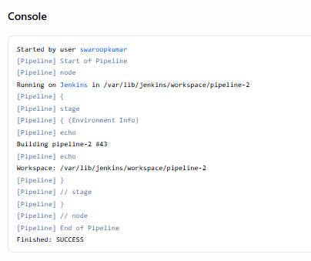
This short snippet prints basic information about the current build environment.
Thus, understanding and utilizing these environment variables effectively can enhance the flexibility of the Jenkins pipeline.

3.2. currentBuild Variables
Further, the currentBuild object provides information specific to the current build. Particularly, it’s useful for making decisions based on the build’s status or properties. Some key currentBuild variables show time data and results:
- currentBuild.result: the result of the build (SUCCESS, FAILURE, UNSTABLE, etc.)
- currentBuild.duration: duration of the build in milliseconds
- currentBuild.previousBuild: information about the previous build
To demonstrate the use of currentBuild variables, let’s look at an example:
pipeline {
agent any

stages {
stage('Build') {
steps {
echo "Starting Build..."

sh '''
echo "Cleaning previous build files..."
mvn clean

echo "Building application..."
mvn package -DskipTests
'''
}
}
}

post {
always {
echo "Build result: ${currentBuild.currentResult}"
echo "Build duration: ${currentBuild.duration}ms"
}

success {
echo "Build completed successfully."
}

failure {
echo "Build failed."
}
}
}
This short snippet defines a basic build process with feedback.
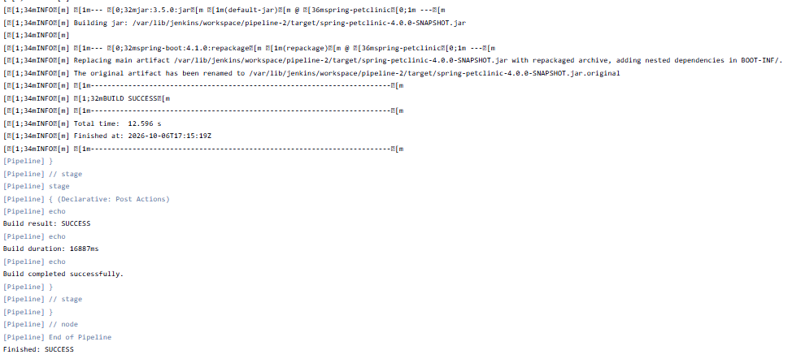

3.3. params Variables
Additionally, the params object enables access to build parameters defined in the job configuration. This is useful for creating flexible, parameterized builds. For example, if we define a parameter named DEPLOY_ENV, we can access it via params:
pipeline {
agent any
parameters {
choice(name: 'DEPLOY_ENV', choices: ['dev', 'staging', 'prod'], description: 'Deployment environment')
}
stages {
stage('Deploy') {
steps {
echo "Deploying to ${params.DEPLOY_ENV} environment"
// deployment steps
}
}
}
}
By using these global variables, we create more dynamic informative pipeline scripts.
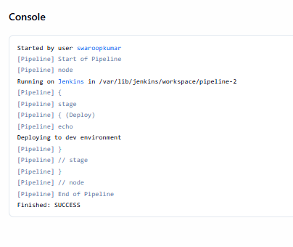

4. Accessing Global Variables
Understanding the correct syntax and usage patterns is crucial for leveraging the full power of global variables.
Also, accessing global variables in the Jenkins pipeline is straightforward, but there are a few syntax rules to keep in mind:
- for most global variables, we can use dot notation: variable.property
- we can access environment variables using env.VARIABLE_NAME or ${VARIABLE_NAME}
- some variables, like currentBuild, have global properties
Let’s examine an example that demonstrates these different syntaxes:
pipeline {
agent any
stages {
stage('Variable Access') {
steps {
echo "Job name: ${env.JOB_NAME}"
echo "Build number: ${BUILD_NUMBER}"
echo "Build result: ${currentBuild.result}"
}
}
}
}
Knowing about each method and syntax can help adapt to the current context.
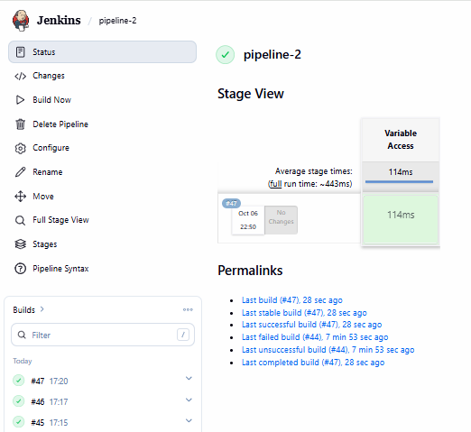

5. Examples of Using Global Variables in Pipeline Scripts
After getting to know global variables and how to access them, let’s see some practical implementations of doing so.

5.1. Conditional Execution Based on Branch Name
To begin with, we can execute code conditionally using the name of a branch.
To further clarify this concept, let’s look at an example to demonstrate it:
pipeline {
agent any
stages {
stage('Deploy') {
when {
expression { env.BRANCH_NAME == 'main' }
}
steps {
echo "Deploying main branch to production"
// deployment steps
}
}
}
}
In the short snippet above, we use the BRANCH_NAME environment variable to conditionally execute the deployment stage only for the main branch.

5.2. Using Build Parameters
Next, let’s look at an example of using a build parameter in a pipeline script:
pipeline {
agent any
parameters {
string(name: 'VERSION', defaultValue: '1.0.0', description: 'Version to deploy')
}
stages {
stage('Deploy') {
steps {
echo "Deploying version ${params.VERSION}"
// deployment steps
}
}
}
}
Here, we define a build parameter VERSION and use it in the pipeline script. This enables us to specify different versions when triggering the build.
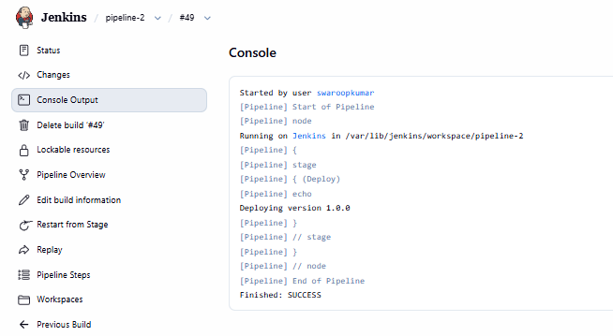

5.3. Handling Build Faliures
In addition, we can send a notification when the build fails.
Let’s look at an example to demonstrate this:
pipeline {
agent any
stages {
stage('Build') {
steps {
// build steps
}
}
}
post {
failure {
mail to: 'team@example.com',
subject: "Failed Pipeline: ${currentBuild.fullDisplayName}",
body: "Something is wrong with ${env.BUILD_URL}"
}
}
}
In this snippet, we use the currentBuild.fullDisplayName and env.BUILD_URL variables to send a detailed email notification when a build fails.

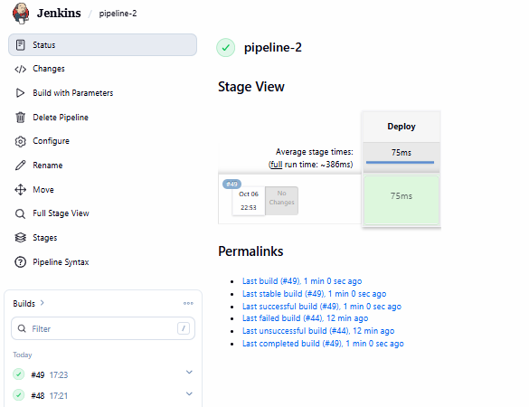

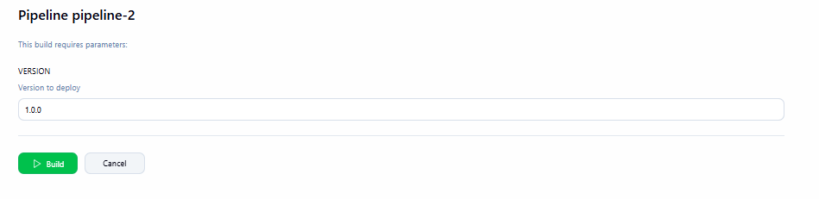

6. Creating Custom Global Variables
While Jenkins provides many built-in global variables, there are times when we need to define custom variables to suit specific needs. In addition to built-in variables, creating custom global variables enables us to extend Jenkins’ functionality and tailor it to unique project requirements.

6.1. Defining Global Variables in Jenkins Configuration
One way to create custom global variables is through the Jenkins system configuration. This method is particularly useful for variables that need to be available across multiple pipelines.
To define a custom global variable:
- Go to Dashboard
- Navigate to Manage Jenkins and select Configure System
- Check the box Environment variables
- Click Add, and enter the name and value of a custom variable
For example, let’s add a variable COMPANY_NAME with the value TechCorp.
Once defined, we can use this variable in any pipeline script:
pipeline {
agent any
stages {
stage('Welcome') {
steps {
echo "Welcome to ${env.COMPANY_NAME}'s Jenkins Pipeline!"
}
}
}
}

Thus, we used env.COMPANY_NAME to display a welcome message.

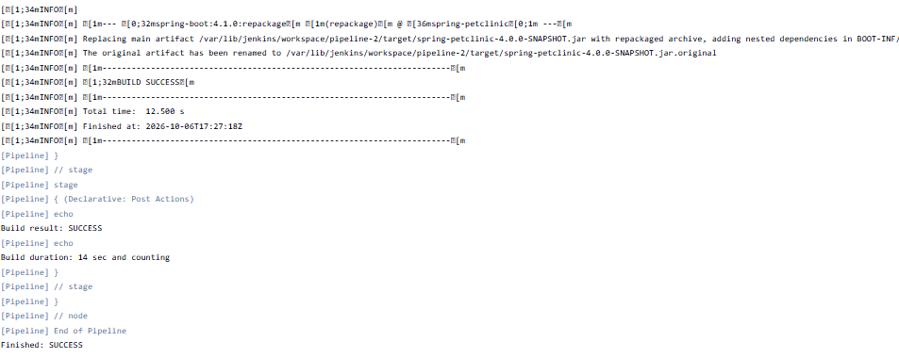6.2. Using Groovy Script for Custom Global Variables
For more complex scenarios, we can use Groovy scripts to define custom global variables. This approach offers greater flexibility and enables us to create dynamic variables based on logic or external factors.
To use this method, we perform two steps:
- Create a Groovy script file (e.g. vars/myCustomVar.groovy) in the Jenkins home directory
- Define a function that returns the desired value
To illustrate this approach, here’s an example of a custom variable that generates a timestamp:
// Filename: vars/getTimestamp.groovy
def call() {
return new Date().format("yyyyMMdd_HHmmss")
}Copy
Now, we can use this custom variable in pipeline scripts:
pipeline {
agent any
stages {
stage('Timestamp') {
steps {
script {
def timestamp = getTimestamp()
echo "Current timestamp: ${timestamp}"
}
}
}
}
}Copy
We can even create more complex custom variables. For instance, here’s a custom variable that fetches the latest Git tag:
// Filename: vars/getLatestTag.groovy
def call() {
return sh(script: 'git describe --tags --abbrev=0', returnStdout: true).trim()
}Copy
Furthermore, let’s look at an approach to use this in a pipeline:
pipeline {
agent any
stages {
stage('Deploy') {
steps {
script {
def latestTag = getLatestTag()
echo "Deploying version: ${latestTag}"
// deployment steps
}
}
}
}
}Copy
Finally, by creating custom global variables, we extend the capabilities of Jenkins to better suit the project needs. Whether it’s through system configuration or Groovy scripts, these custom variables enable us to create more powerful, flexible, and project-specific pipeline scripts.

7. Conclusion
In this article, we talked about global variables in the Jenkins pipeline. Specifically, we saw their uses, functions, and practical applications.
In summary, by leveraging global variables we can create more robust and intelligent pipelines that are more easily customizable.

TASK -10 Get Last Successful Build Status in Jenkins

1. Overview
Jenkins provides a set of remote access APIs and endpoints that enable users to get information, trigger builds, and configure new jobs. One of the common usages of these APIs is to retrieve the status of specific builds.
In this tutorial, we’ll cover how to get the last successful build information using the Jenkins APIs.

2. Get Last Successful Build Using curl
The simplest way to retrieve Jenkins build information is by using curl. curl is a command line utility that we can use to send data through common protocols such as HTTP, and it comes by default with most Linux distributions. So, we can query the Jenkins REST API by using curl directly from a Linux machine.
To send a request to the Jenkins API, the request needs to be authenticated. The first step we need to do before using the curl command is to generate an API token for our user. To do this, we simply go to the user dashboard from the Jenkins UI and then generate the token:
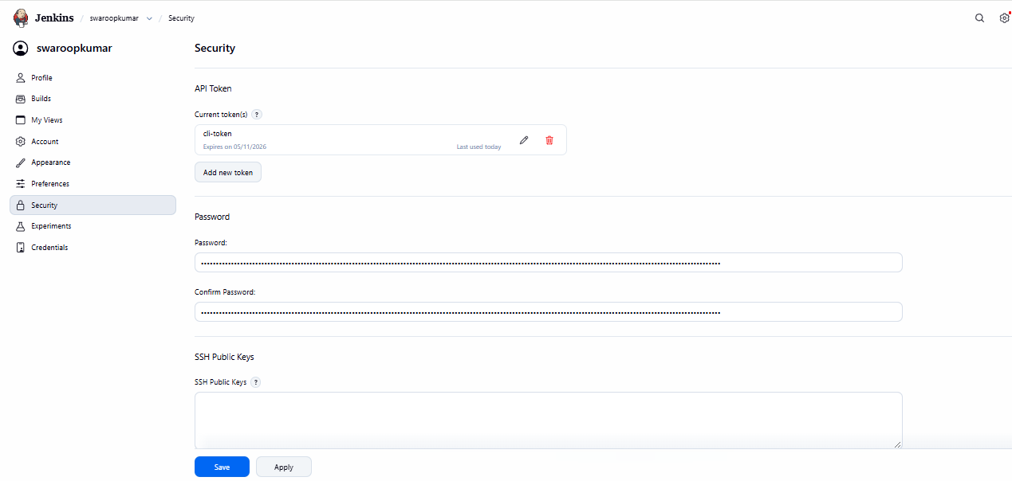
API NEW TOKEN :
Cli token : 111f70fab120b455cb87eb57e8800b4b31

Once we have our token, the next step is to use it in our curl command. To retrieve the last successful build of a job, we send our request to the Jenkins instance IP/hostname followed by the endpoint /job/jobname/lastSuccessfulBuild/buildNumber:
$ curl --user {user}:{token} http://localhost:8080/job/test-job/lastSuccessfulBuild/buildNumber
1Copy
In the above example, we used the –user option to provide the credentials to the curl command. We issued the command from the same machine where Jenkins is installed so we used localhost as the hostname, and the default Jenkins port 8080. Finally, we provided the endpoint for the last successful build with the job name test-job.
We can verify the result by checking the job from the Jenkins UI:

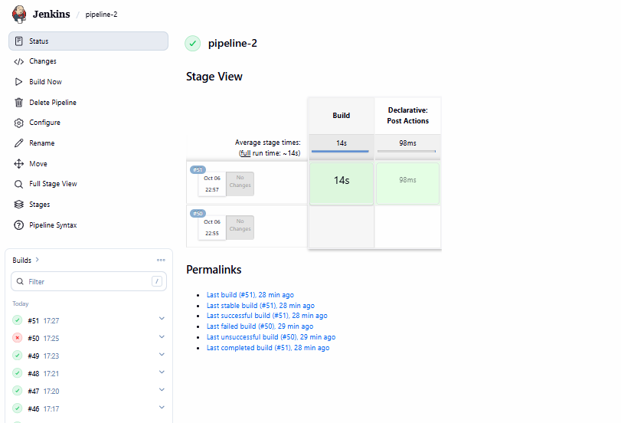
As we can see, the last successful build number of the job is #1, which is matching the output of the curl command.
We can also get the last build and last failed build by changing the endpoint:
$ curl --user {user}:{token} http://localhost:8080/job/test-job/lastBuild/buildNumber
3
$ curl --user {user}:{token} http://localhost:8080/job/test-job/lastFailedBuild/buildNumber
2
In this example, we replaced the lastSuccessfulBuild in the URL with lastBuild and lastFailedBuild. The output returned is matching the build numbers we saw in the Jenkins UI.

3. Get Last Successful Build Using a Jenkins Pipeline
If we don’t prefer using the raw REST API, we have other options to retrieve information from Jenkins. There are language wrappers that consume the Jenkins API and we can use them directly. A common example would be to use the Java or Groovy Jenkins.model.jenkins class inside a pipeline script. So, we can create a pipeline that retrieves the build status of other jobs inside Jenkins.
Let’s check this with an example:
pipeline {
agent any
stages {
stage("get build status"){
steps {
script {
def jobName = Jenkins.instance.getItem("test-job")
echo "${jobName.getLastSuccessfulBuild()}"
echo "${jobName.getLastFailedBuild()}"
echo "${jobName.getLastBuild()}"
}
}
}
}
}
In the above example, we created a pipeline script that retrieves different build statuses of our test-job. The Jenkins.instance.getItem() is a method of the Jenkins.model.jenkins class that returns an item object, which is the test-job in our example.
After that, we use the getLastSuccessfulBuild(), getLastFailedBuild(), and getLastBuild() methods of the test-job item to get the corresponding build for each status.
Now let’s see the output of this pipeline:

4. Conclusion
In this article, we’ve covered how to retrieve a Jenkins job build status. Jenkins allows remote access to get this information through a set of REST APIs which can be consumed directly or by using a language wrapper. We can retrieve a build status information using a tool like curl by sending HTTP requests to the appropriate endpoint. We can also use a Groovy script directly inside a Jenkins pipeline to retrieve the same information.

